With SIRTA, the online reservation site available from 7 a.m. to 9 p.m., you can reserve a ride or cancel another one. Avoid waiting for the call centre while making it easier on yourself!

1. Registration 2
2. Overview of your file 2
3. Your profile 2
4. Request for occasional transportation: 3
5. My confirmed trips for the next 7 days 5
6. Request for regular reservation: after deciding if you want a one-way ride or a return trip, you must enter the required information: 6
7. My regular transportation schedule 8
8. Processing requests for regular transportation……………………………………………………………………………..9

- Registration: once you are on the SIRTA home page, you must enter your file number and password. It’s the same password you use for Transport adapté’s automated telephone services.

When you use the online reservation service for the first time, you must enter the month and date of your birth as your initial password (if you were born on September 14, your password would be 0914). Afterwards, you can create a new internet password before making that first reservation. Your new password must consist of 8 characters, including at least 1 number, e. g. sunshine29.
If you forgot your password, or wish to voice any other comment, please contact us by email or by telephone at 514 280-8211 option 4 (Monday to Friday).

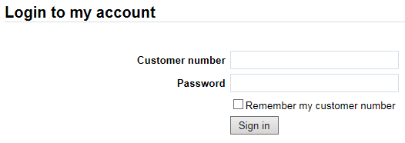
File number

- Overview of your file: once you are registered, you can view all relevant information in your reservation file.

- My profile: information contained in your Transport adapté file:
- Customer number
- Home address
- Telephone
- Mobility device
- Travel companion
- Modify my password

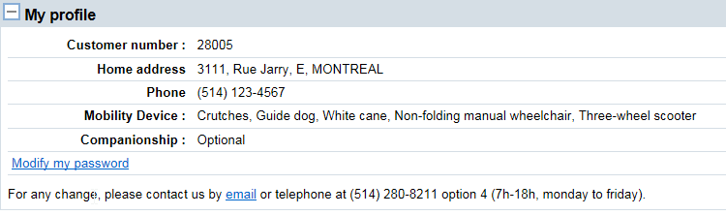

- Request for occasional transportation: after deciding if you want a one-way ride or a return trip, you must enter the required travel information:
  - Date and time
  - Address
  - Mobility device, if applicable (field appears based on profile)
  - Travel companion, if applicable (field appears based on profile)

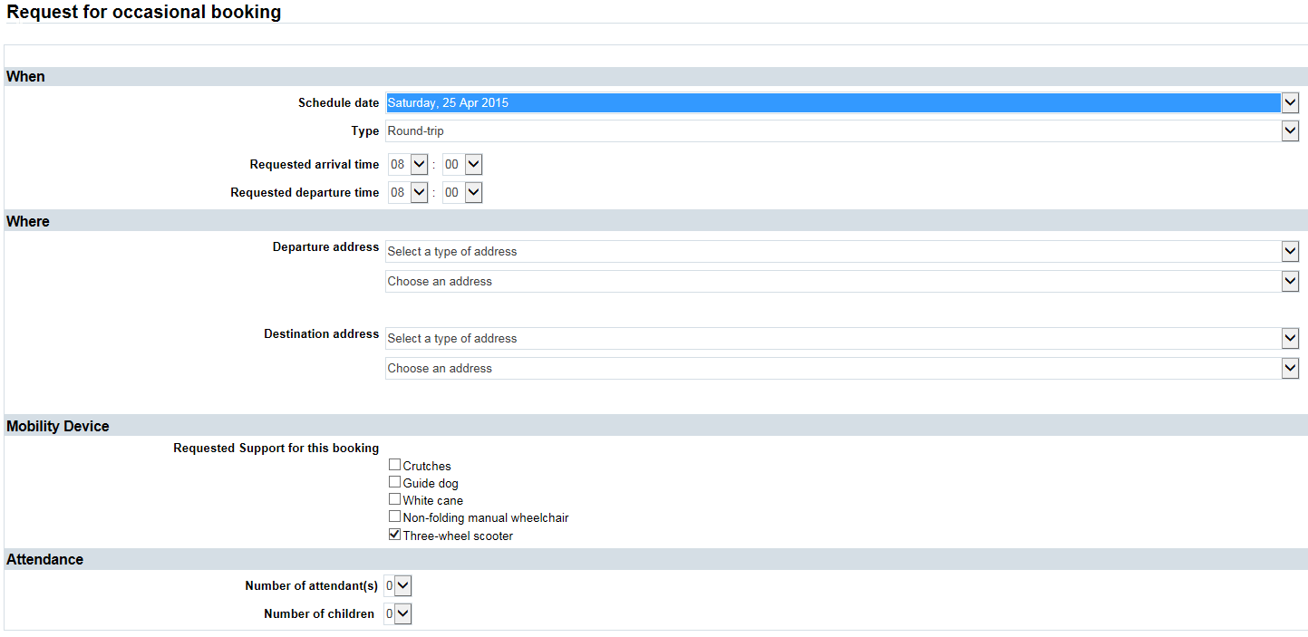
You need to specify if that address is among your preferred addresses or in your recent trip history. Or you can use the list of public places sorted by type of destination.
These fields appear if required by your file.

Once your reservation is confirmed, you can then modify or cancel it if necessary.

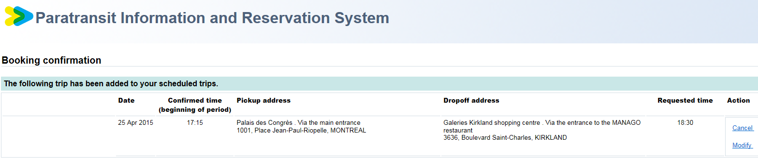

My confirmed trips for the next 7 days
You can view your trip reservations for the next 7 days, regardless of whether they were made by telephone or online.

A useful tool for:
- Having a comprehensive view of your upcoming trips so you can enter them in your day planner
- Making sure your reservation was correctly registered in the system
- Cancelling a scheduled trip
- Reporting a late vehicle once the 30-minute window for arrival is up.

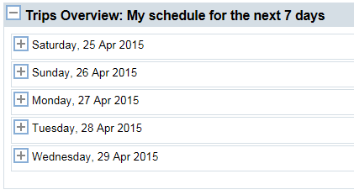

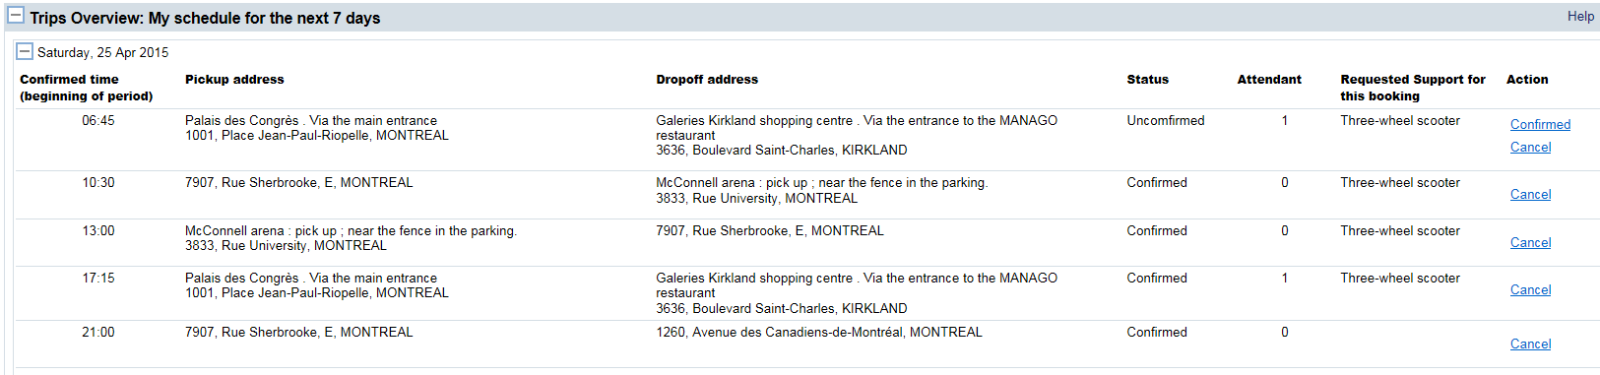

Request for regular transportation: after deciding if you want a one-way ride or a return trip, you must enter the required information:
  - Requested day(s) and date(s)
  - Address
  - Mobility device, if applicable (field appears based on profile)
  - Travel companion, if applicable (field appears based on profile)
  - Comment (specify if trip is for hemodialysis)

Expect a 10- to 20-day waiting period before obtaining confirmation for your regular schedule of trips, as this will require special programming in the system by a Transport adapté staff member. You will first see your request for regular transportation appear in « Processing requests for regular transportation », then in « My regular trips » once it has been confirmed.

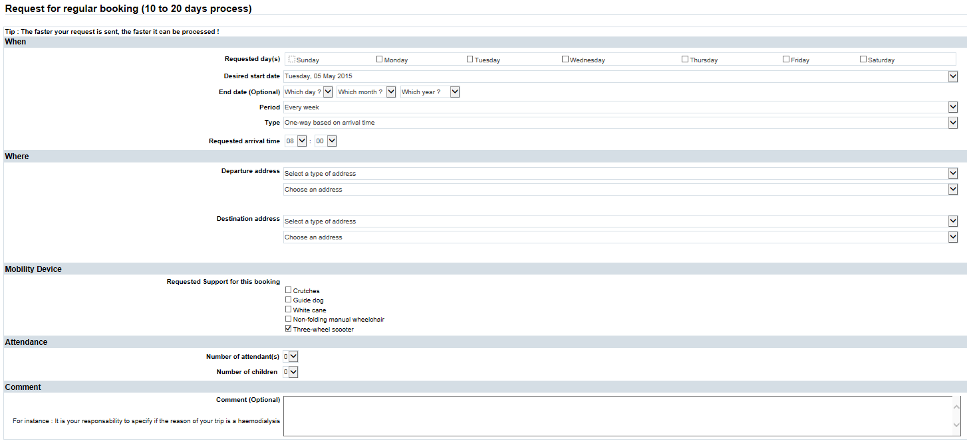
You need to specify if that address is among your preferred addresses or in your recent trip history. Or you can use the list of public places sorted by type of destination.

These fields appear if required by your file.

My regular transportation schedule
You can view the reservations for the regular trips registered in your file, regardless of whether they were made by telephone or online.

A useful tool for:
- Having a comprehensive view of your upcoming trips so you can enter them in your day planner
- Making sure your reservation was correctly registered in the system
- Suspending regular transportation (for a maximum of 8 consecutive weeks)
- Permanently cancelling a regular transportation schedule

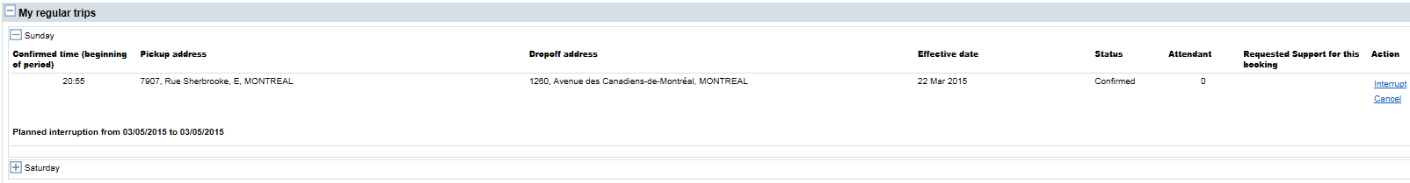

Processing requests for regular transportation
You can view your requests for regular transportation that are being processed, regardless of whether they were made by telephone or online. A 10 to 20-day period is needed for processing. Once your trip is confirmed, it will appear under « My regular trips ». If necessary, you may still cancel your request for transportation.

