(pour site internet)
LIST OF PUBLIC PLACES IN SIRTA
Click here for instructions to access the complete list of public places available in SIRTA. This is a list of places that are frequently visited by Transport adapté customers.
http://www.stm.info/fr/ta (francais)
http://www.stm.info/en/para (anglais)

--
Here are the instructions to access the complete list of public places available in SIRTA. This is a list of places that are frequently visited by Transport adapté customers.
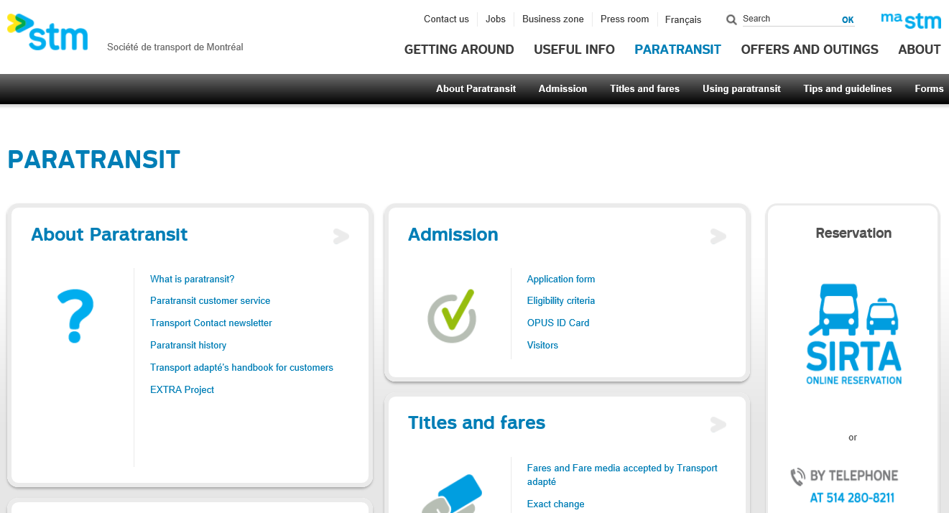
Cliquer ici

After opening SIRTA, enter your file number and password.
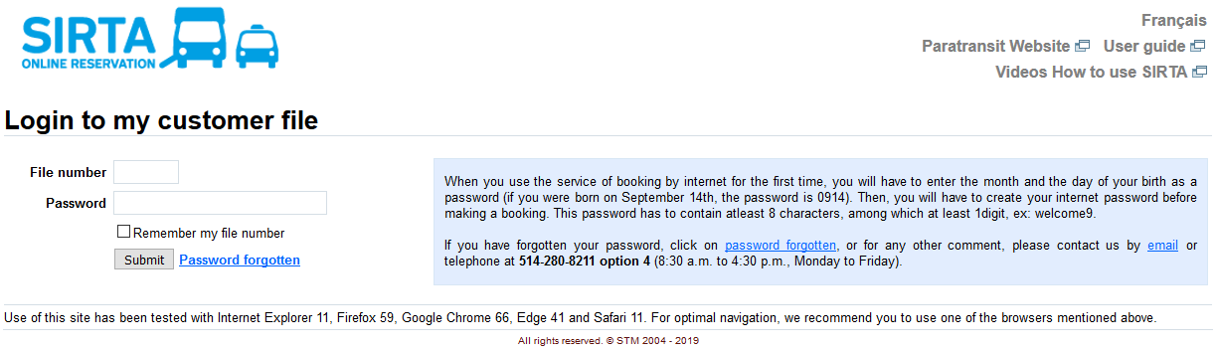

Note: If this is your first time using the online reservation service, you will have to enter the month and day of your birth as a password (if you were born on September 14, your password is 0914). Then you will have to create an internet password before making a reservation. The password must have at least eight characters, including at least one number. E.g., welcome9.

Under “Request for occasional transportation,” click “Create a one-way trip.”
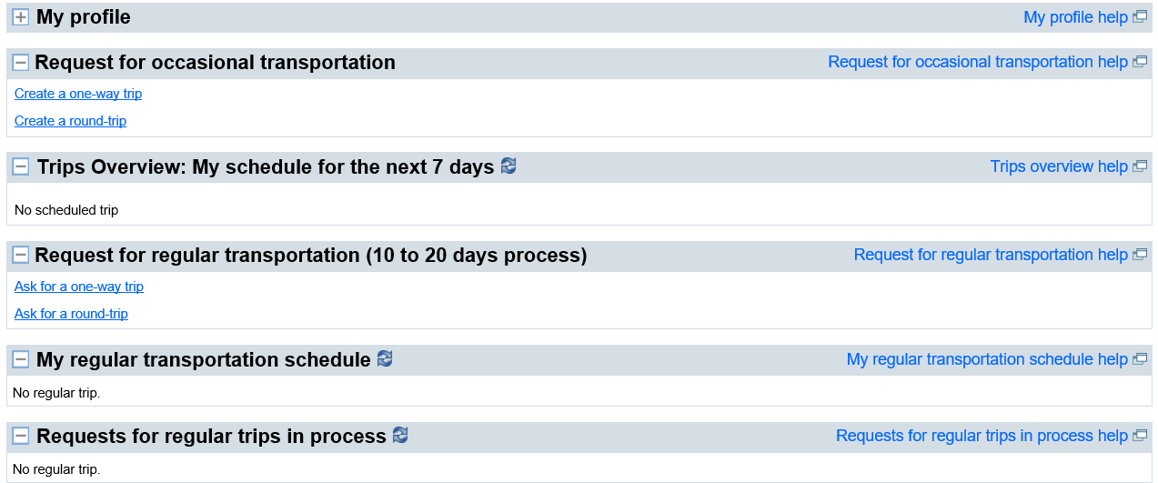

Under “Departure address,” click the arrow to the right of “Select a type of address” to see the list of options.
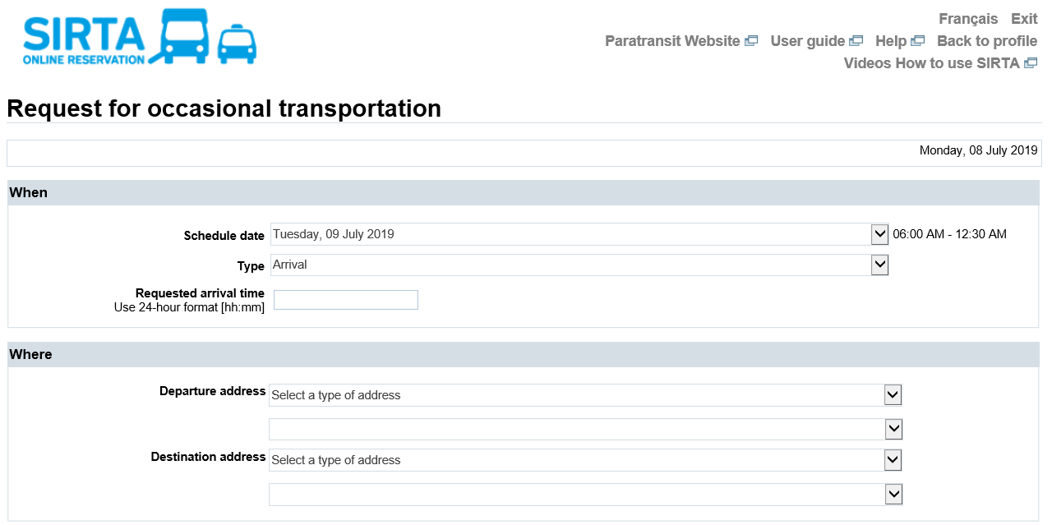

Select “Public places by address” or “Public places by name.”
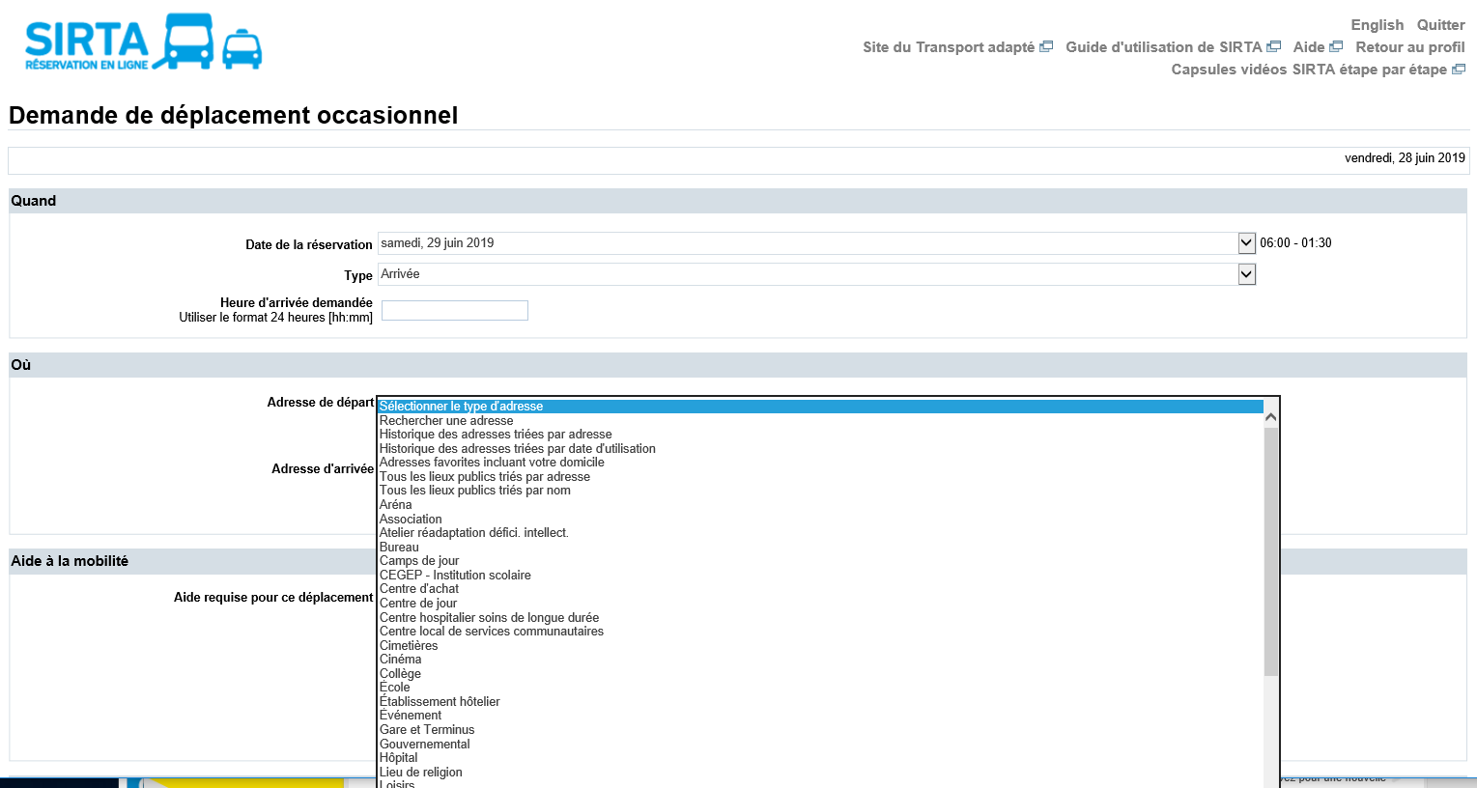

Then click “Choose an address.” The list of public places will appear:
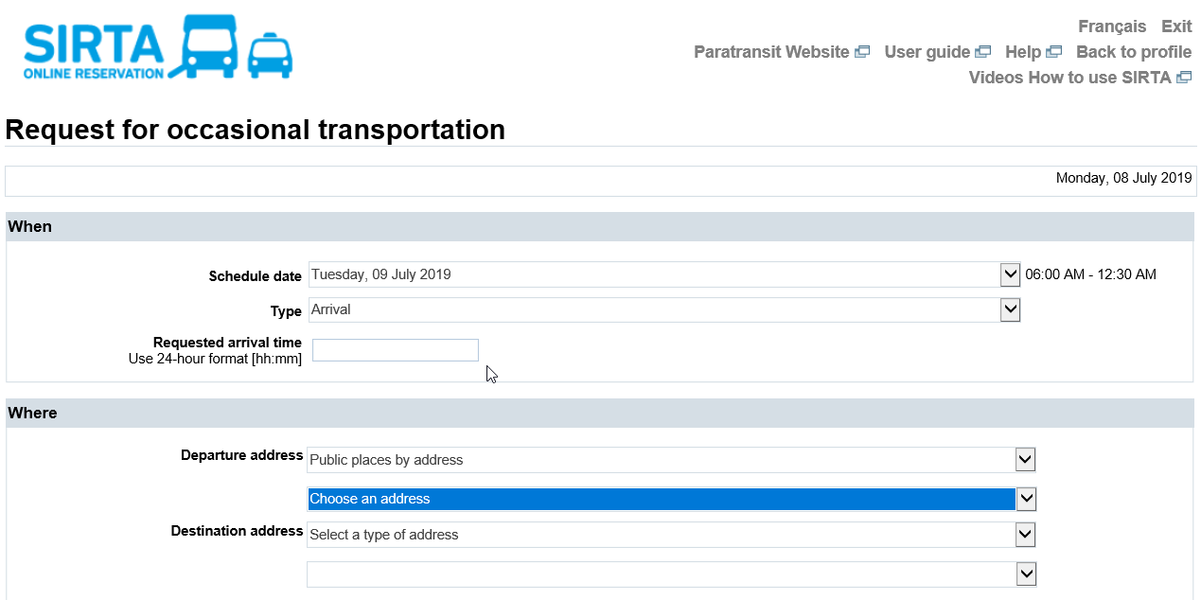

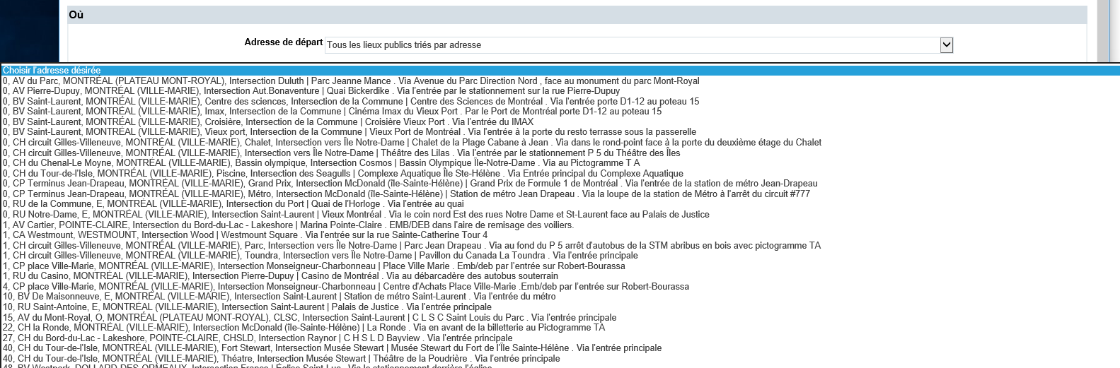

For more information about our list of public places, call us at 514-280-8211 (Teletype: 514-280-5308).

