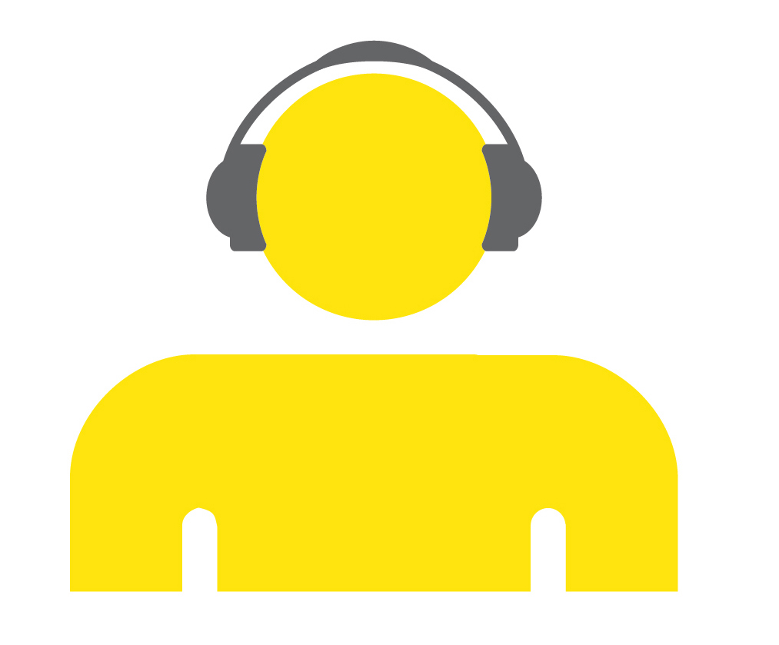
Buying transit fares at fare vending machines:
instructions for using the audio interface
November 2018 update


Paying for OPUS with your headset 3
User support 3
The fare vending machine (DAT) 3
How to use the DAT to buy a fare or reload your OPUS card 4
The OPUS main screen 4
The banking keypad and debit/credit card reader 5
Cancelling a payment on the banking keypad 6
Payment and reimbursement of a cash purchase on the DAT 6
Receipt and transit fare card dispenser 6
The reloading terminal (BR) 7
How to reload your OPUS card at the BR 7
The OPUS main screen 7
The banking keypad and debit/credit card reader 8
DAT and BR location 9
Conclusion 9

Paying for OPUS with your headset
The system for buying metropolitan transit fares includes two machines: the larger fare vending machine (DAT) and the smaller OPUS card reloading terminal (BR).These machines can be used to buy a reloadable OPUS card, purchase a single-use transit fare card or reload your OPUS card. You will find these machines at métro and train stations, and some bus terminals.
It is important to understand that the procedure sequence is identical for all users, whether or not you are using audio messages. To facilitate your transactions, keep in mind that you will have to navigate between two areas of the machines, beginning with the OPUS main screen, followed by the banking keypad and ending with the OPUS main screen.
If the audio component of these machines malfunctions, notify the staff on hand at the métro or train station. You can also call 514-786-4636, option 4, for métro station equipment, or 1-888-702-8726 for terminal or train station equipment.

User support
Remember that you need to supply your own headset when buying a fare. An audio message will help guide you through your transaction. Listen carefully to the audio instructions before performing an action on the DAT. To replay a DAT message, go back to the previous step by pressing either the “cancel” button or the navigation buttons. Inserting coins or an OPUS or bank card, or pressing a key will interrupt the audio message. To go back to the previous step, press the “cancel” button and listen to the message again.

The fare vending machine (DAT)
The DAT, which is about the size of a refrigerator, is an automatic teller that is not built into a métro station wall. The DAT has an inclined surface, with a main screen located to the left. Four round buttons on each side of the screen allow you to select a fare or reload your OPUS card. A round “cancel” button is located below the main screen. A card slot to the right of the main screen allows you to insert your OPUS card vertically. A banking keypad framed by two metal shields is located further to the right. Above it, on the vertical surface, is a debit/credit card reader. A coin slot is located to the right of the reader. The headset plug and volume button are lower down on the inclined surface.The banknote reader for your cash transactions is located below the main screen to the left. To the right, well below the banking keypad, is the receipt dispenser with a moveable flap and a slot from which you can retrieve your receipts and tickets.

How to use the DAT to buy a fare or reload your OPUS card
Prior to each transaction, plug in your headset before inserting your OPUS card and adjust the volume by pressing the button located above the headset plug. You can increase the volume by pressing the button once or twice. Pressing the button a third time gradually lowers the volume. Remember that performing an action on the DAT will interrupt the audio message, but not the current transaction.

The OPUS main screen
Function buttons are located on each side of the screen: to the left, from top to bottom, are buttons 1, 2, 3 and 4 and, to the right, also from top to bottom, are buttons 5, 6, 7 and 8. Buttons 4 and 8 allow users to navigate the pages of the main screen, while the other buttons are used to select the desired fare. The round “cancel” button is located below the screen.
You can buy a transit fare with or without an OPUS card. Now, you can also buy an OPUS card directly from a DAT. Note that OPUS cards purchased from a DAT are regular cards, with no photo ID or access to reduced fares. Access to reduced fares requires a photo ID OPUS card.
If you have an OPUS card, insert it vertically, right-side up, into the card slot with a curved surface, to the right of buttons 6 and 7. Be sure that the card is inserted vertically. Once your OPUS card has been inserted, the content is displayed based on your previous purchases (e.g., monthly pass, number of remaining fares) and the expiry date of these fares. You can then choose your transit fare. Note that the order of transit fares displayed on the screen varies according to the date of your purchase and the location of the DAT. IMPORTANT: Do not remove your OPUS card until you hear the prompt at the end of your transaction.
If you do not have an OPUS card, you have two options. To buy a fare on a non-reloadable card, press 8. If you want to buy an OPUS card, press 7. Below the main screen, to the left, is a slot for inserting unfolded banknotes one at a time, while the coin slot is located to the right of the banknote reader. Note that the maximum amount for a cash transaction is $80. Also note that, since banknotes may be rejected, it is recommended that you hold your hand in front of the slot to keep them from falling on the ground.

The banking keypad and debit/credit card reader
Once you choose payment by bank card, remember that the OPUS main screen functions, including the “cancel” button, will be deactivated. The banking keypad, located to the right of the main screen between two metal shields, has two round tactile markers touch features, one on each side. The one on the left is located between keys 4 and 7, and the one on the right between keys 6 and 9. The keypad keys resemble those of a telephone. Key 5, in the centre, has a tactile dot.
To the right of the telephone-type keypad are three square keys. From top to bottom, the “cancel” key has an embossed “x”, the “correction” key has a less-than sign, and the “OK” key has an embossed circle. The “cancel” key with an embossed “x” allows you to go back to the main screen to choose the method of payment and use the main screen buttons.
The chip and magnetic strip bank card reader is located above the keypad. When you insert your bank card horizontally, be sure that the writing on the card is facing upward and to the left. If the card is inserted correctly, you will be asked to confirm the transaction amount, and you will be guided through your banking transaction. If the card is inserted incorrectly, the audio explanations will continue as though you had not inserted your card. In that case, cancel the bank transaction by pressing the “cancel” key with an embossed “x”. You will then be redirected to the page where you can choose your method of payment, and you can start the bank transaction over. The transit fare will remain valid. As soon as you enter your PIN, the “cancel” key on the banking keypad will be deactivated. If you enter an incorrect PIN, you will be asked to re-enter it. When you press a bank keypad key, you will hear a confirmation “beep” indicating that you have entered each digit of your PIN. Once you have completed your transaction, remember to retrieve your receipts, transit fare cards and coins from the receipt dispenser with a moveable flap located below the banking keypad.

Cancelling a payment on the banking keypad
If you want to cancel your banking transaction, press the “cancel” key with an embossed “x” on the banking keypad and not the “cancel” key on the main screen. As soon as you enter your PIN, the “cancel” key on the banking keypad will be deactivated.

Payment and reimbursement of a cash purchase on the DAT
You can interrupt a cash purchase provided that you have not inserted the total amount into the machine. Since any banknotes that you have inserted may be rejected, remember to hold your hand in front of the slot to keep them from falling on the ground.

Receipt and transit fare card dispenser
Receipts and transit fares can be retrieved from the dispenser with a moveable flap located below the banking keypad. So you can tell them apart, the receipt is printed on rigid cardboard and the magnetic card has a small notch along its edge. Occasional smart cards are printed on glossy paper. As a precaution, we recommend that you avoid folding the transit fare cards and that you always keep your receipts.

The reloading terminal (BR)
Smaller than the DAT, the BR is comparable in size to a métro turnstile casing. The BR is designed exclusively for reloading OPUS cards and accepts OPUS cards and debit/credit cards but not cash. You cannot use it to buy an OPUS card or a single-use transit fare.
The BR has a main screen, with four square buttons on each side. To the left, below the screen, from top to bottom, are the following three components: the round “cancel” button, the slot into which you insert your OPUS card vertically and the receipt dispenser. To the right, well below the main screen, is the banking keypad and, below that, the chip debit/credit card reader. A headset plug and volume button are located just to the right.

How to reload your OPUS card at the BR

The OPUS main screen
Square function buttons are located on each side of the screen. To the left, from top to bottom, are buttons 1, 2, 3 and 4 and, to the right, also from top to bottom, are buttons 5, 6, 7 and 8. Buttons 4 and 8 allow users to navigate the pages of the main screen, while the other buttons are used to select the desired fare. The round “cancel” button is below the screen.
First, insert your OPUS card vertically into the card slot below the round “cancel” button. Insert the card, right-side up, into the card slot with a curved surface. Be sure that the card is inserted vertically. Once your OPUS card has been inserted, the content (e.g., monthly or weekly pass, number of remaining fares) and the expiry date of these fares will be displayed. You can then choose your transit fare on screen. The list of available transit fares varies according to the date of your purchase.
Next, you will leave the OPUS screen and go to the banking keypad keys. Remember that the OPUS main screen functions, including the “cancel” button, are now deactivated. Do not remove your OPUS card until you hear the prompt at the end of your transaction.

The banking keypad and debit/credit card reader
Remember that the OPUS main screen functions, including the “cancel” button, will be deactivated as soon as you are asked to insert your bank card. The banking keypad is located under the main screen, to the right. Pay special attention to the two round tactile markers located on each side of the banking keypad. The one on the left is located between keys 4 and 7, and the one on the right, between keys 6 and 9. The keypad keys resemble those of a telephone. Key 5, in the centre, has a tactile dot. To the right of the telephone-type keypad are three square function keys. From top to bottom, the “cancel” key has an embossed “x”, the “correction” key has a less-than sign and the “OK” key has an embossed circle. The “cancel” key with an embossed “x” allows you to go back to the main screen to choose the method of payment and use the main screen buttons.
The debit/credit card reader is located below the banking keypad. When you insert your bank card horizontally, be sure that the writing on the card is facing upward and to the left. If the card is inserted correctly, you will be asked to confirm the transaction amount, and you will be guided through your banking transaction. If the card is inserted incorrectly, the audio explanations will continue as though you had not inserted your card. In that case, cancel the bank transaction by pressing the “cancel” key with an embossed “x”. You will then be redirected to the page where you can choose your method of payment, and you can start the bank transaction over. The transit fare will remain valid for three tries, after which you must return to the home page to start the entire transaction over.
As soon as you enter your PIN, the “cancel” key on the banking keypad will be deactivated. If you enter an incorrect PIN, you will be asked to re-enter it. When you press a bank keypad key, you will hear a confirmation “beep” indicating that you have entered each digit of your PIN.
Do not remove your OPUS card until you hear the prompt at the end of your transaction. Remember to retrieve your receipt from the dispenser below the OPUS card slot by pulling downward.
The volume button and headset plug are located just to the right of the chip debit/credit card reader. To increase the volume, press the button once or twice. Pressing the button a third time gradually lowers the volume.

DAT and BR location
Depending on their location, the DATs do not all offer the same fares, and the list of fares available varies throughout the month.

Conclusion
The audio function added to DATs and BRs is intended to give you autonomous access to public transportation networks in the Montréal area.
The Institut Nazareth et Louis-Braille’s cooperation in carrying out this joint project, along with the valuable contribution of partners in the community, the Regroupement des aveugles et amblyopes du Montréal métropolitain, the Regroupement des usagers du transport adapté et accessible de l’île de Montréal and the MAB-Mackay Rehabilitation Centre, will go a long way to ensuring the project’s success, and we take this opportunity to thank them.



