Transport contact December 2010

Communication and information bulletin for paratransit services users

OPEN HOUSE AT THE CENTRE DE TRANSPORT ADAPTÉ

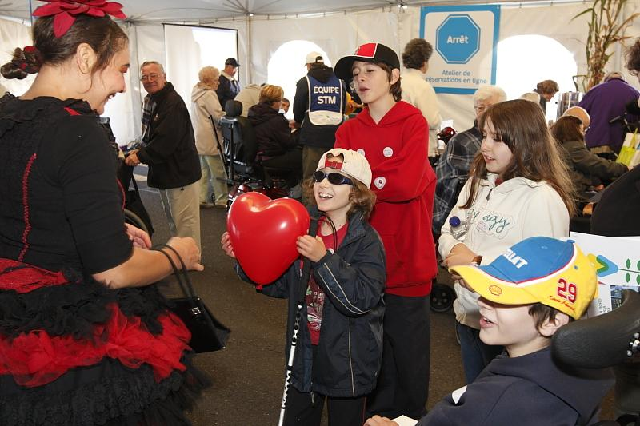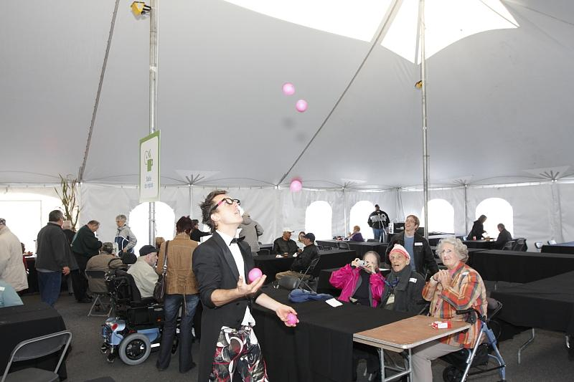

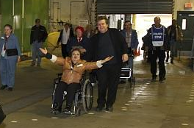

A wonderful family celebration!

Open house at transport adapté : A huge success!

On Sunday, October 3, an Open House was held at Transport adapté. Close to 1 100 clients responded to the invitation to come and explore the centre where 265 employees work seven days a week to plan and organize your trips. Even the sun made an appearance at the get-together!

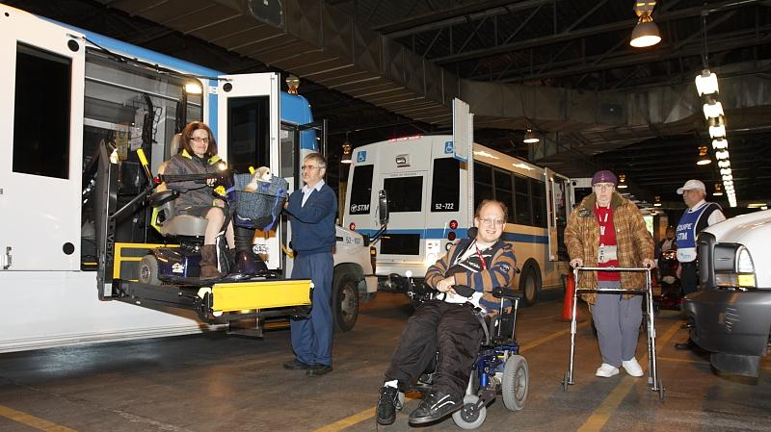
Arrival – Visitors disembark inside the garage section of the Centre de transport adapté.

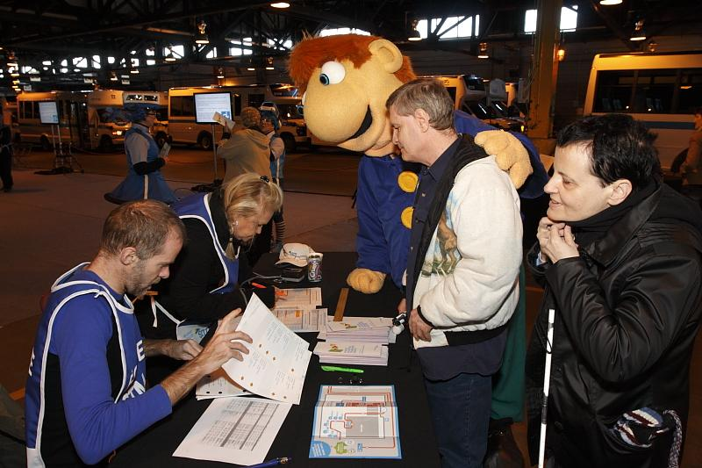
Registration – It takes organization to transport and greet 1 100 people. This is why visitors had to be registered. Alain Petit and Josée Daneau confirm the registrations of two visitors.
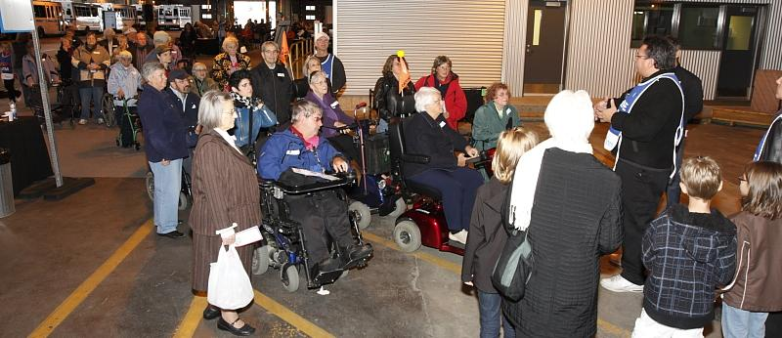
Start of the tour – Sylvain St-Denis explains to a group how the tour will unfold.

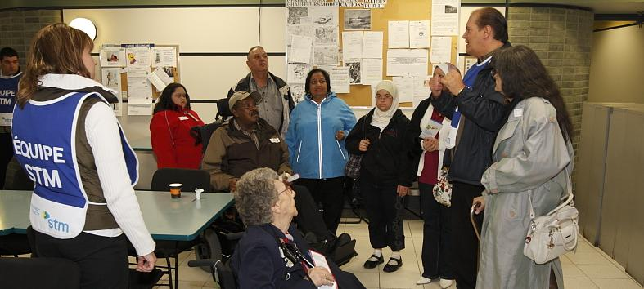
Offices – Daniel Picotte shows visitors around the drivers’ room and offices.

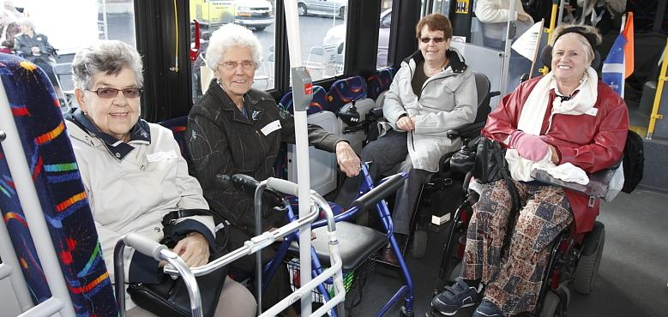
Low-floor bus – Taking advantage of a break, these ladies killed two birds
with one stone by trying out a low-floor bus. Judging by their big smiles, it seems
they like the accessibility offered by this type of bus.
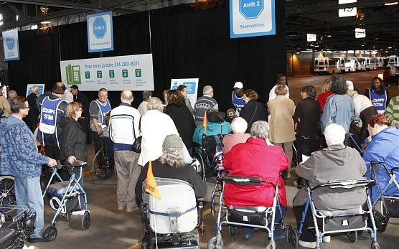
Kiosks – Several kiosks provided information to visitors. Above: reservations, trip
information, customer service.

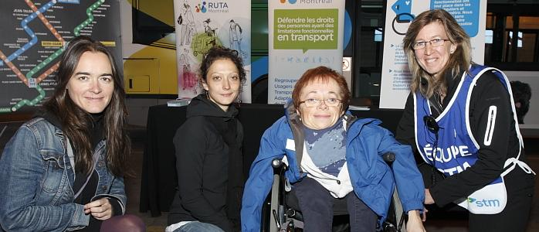
At the kiosk featuring RUTA and universal accessibility, our photographer snapped a photo of Mathilde Le Bouëdec, Valérie Larouche, Marie Turcotte and Liette Vinet.

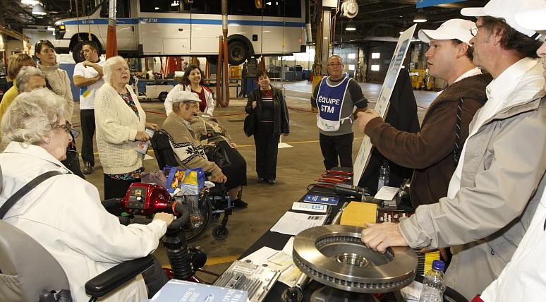
Adélard Duperron and Julien Roussel talk about engines to intrigued visitors at the kiosk on minibus maintenance.

Winners of the draw
Visitors to the Internet reservation kiosk could participate in a draw. On October 14, the management team at Transport adapté drew the winners’ names, with each winner receiving a gift certificate from Archambault. Mariette El Raheb, Diane Robidas, Doris Ramlall and Lina Pipitone Congratulations to our winners!

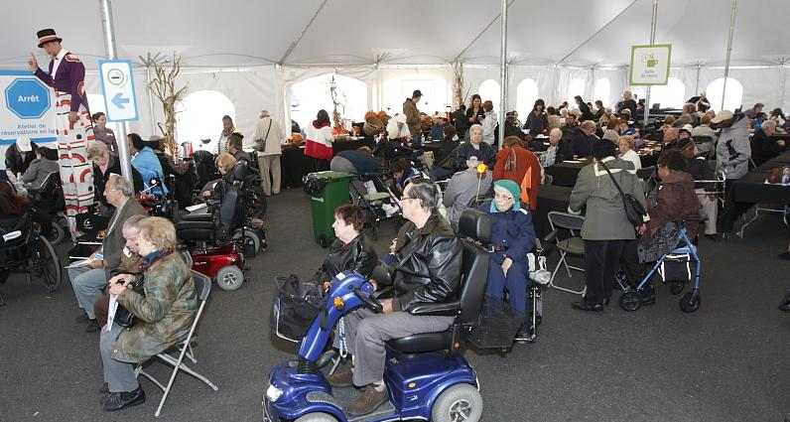
Under the big top – At the end of the visit, guests were able to enjoy a light snack and delight in the clowns, mascots and acrobats under the shelter of a large tent.

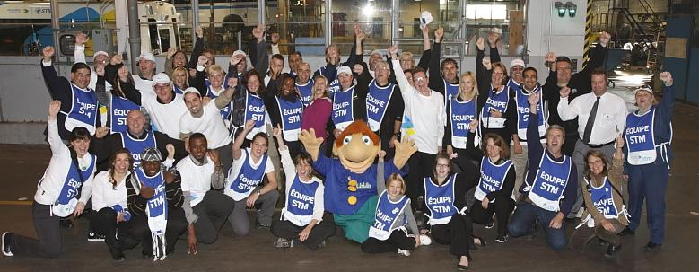
Proud employees
The volunteers were full of pride and emotion at the end of the day.

“The day provided wonderful exchanges and moments of emotion,
which will remain engraved in our memories.”

Liette Vinet, Director of Transport adapté


Quality of service a key

Factor at Transport adapté

STM Transport adapté

customer satisfaction survey

Transport adapté conducted a telephone survey in
May 2010 to measure the satisfaction level of its clientele. A total of 904 clients were asked about their degree of satisfaction with our various services.

We are very proud of the response received. The level of customer satisfaction with Transport adapté services was 94%. This represents an impressive gain of 13 points in comparison with the 2008 survey. The chart below indicates that customer satisfaction is up for all Transport adapté services.

Our efforts rewarded
We are especially proud of this positive result as it rewards the work undertaken by all employees at Transport adapté to improve services.

The call centres succeeded in answering more calls and reducing the waiting time. But access to the call centres remains a constant concern, because the more we improve it, the more requests we receive from you. To help us deal more efficiently with the growing demand for trips, we suggest that you use our Internet reservation system.

You indicated that you greatly appreciate the courtesy of our employees, whether it’s the call centre employees or our minibus drivers. The availability and quality of our minibus and taxi services have clearly improved, particularly the service by accessible taxi.

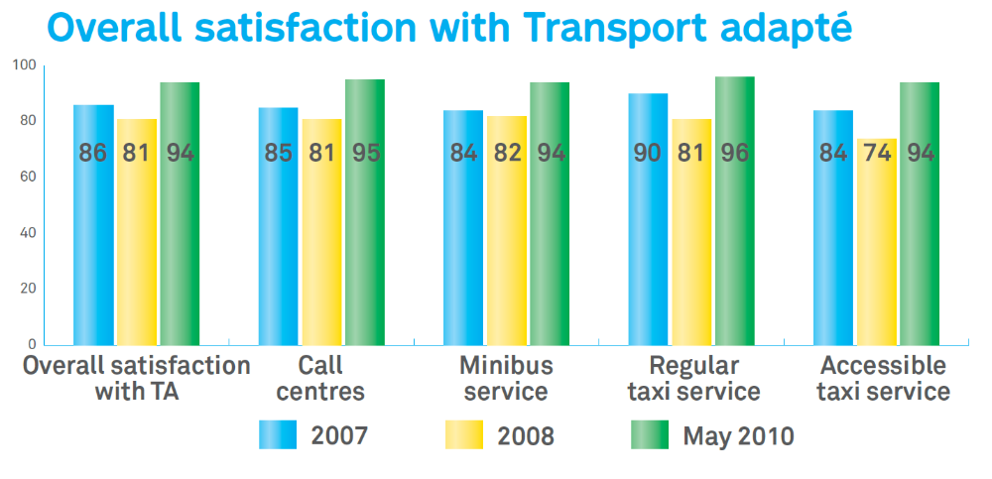
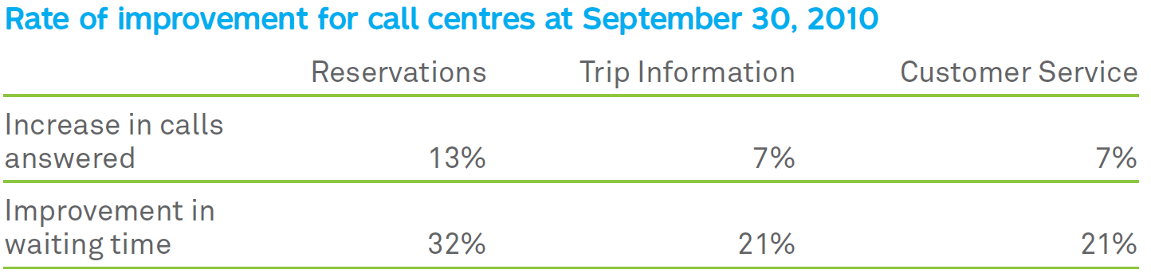

And it won’t stop there!

We’re not resting on our laurels! On the contrary, we’ll continue to work to improve
our services even more. You have let us know about your expectations regarding
improvement in the comfort of minibuses; we believe you’ll see a positive change
with the arrival of 14 new vehicles in the spring of 2011.

This survey will be repeated every year, because we want to stay focused on the
key concern of our clients: quality of service.

To reserve more quickly: Internet Reservation

Do as 1126 of our clients do, and make your reservations yourself on the Internet. Simply click on the “Internet Reservation” link on Transport adapté’s home page at
www.stm.info/English/t-adapte/a-index.htm. If you’re doing it for the first time, you’ll find a user guide there to help you out.

Quality service at a fair price

Every year Transport adapté uses mystery clients to make sure our clients are being well served.

A mystery client is a “fake” client who uses Transport adapté in the same way a regular client would. Through all stages of the trip, the mystery client verifies that the service is being carried out the way it should be. These visits also enable us to determine if the billing from the taxi companies reflects the services provided, thus ensuring that the STM is paying a fair price.

In addition to verifying the quality of the service, these evaluations allow us to
determine what can be improved.


The STM, the best in North America!
This fall, the STM received one of the greatest honours that can
be bestowed on a transportation company. The award as the
Outstanding Public Transportation System in North America
was in recognition of the excellent results it achieved in terms of
effectiveness and efficiency. This award is presented each year by the American Public Transportation Association (APTA), which is made up of 1 500 transportation organizations.

This recognition also rewards the work of all the employees of the STM, who redouble their efforts every day to serve you better. To us, public transit is, above all, a sustainable development project. We work alongside our clients on a day-to day basis to make our city a place where we can breathe more easily.
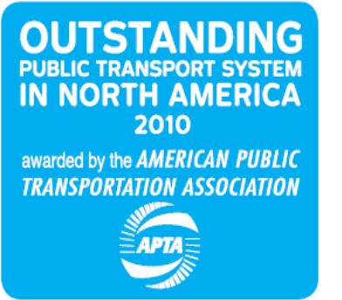
“I’m very proud of this award. It’s as if the STM has just won the Stanley Cup of its industry. I share my pride with all the employees who do a fantastic job and who redouble their efforts every day to provide our clientele with a quality service.”

Mr. Yves Devin, Director General of the STM

Going to the shopping centre?
Please get on and off at the Transport adapté stop!
Shopping centres are so vast that there must be a designated meeting point. The Transport adapté stops are there to make it easier for clients and drivers to find each other.

So, the next time you’re going shopping, get off and on at the Transport adapté stop to be sure you’ll meet up!

List of public places on the Web site
The list of public places served by Transport adapté is available on Transport
adapté’s Internet site. The document is provided in both Word and PDF formats. This list will be useful to make your occasional reservations with the automated
services. The list is sorted by types of places. For example, if you wish to make a
reservation for transportation to a hospital, consult the “Hospitals” section in the list. There you will find the hospitals served by Transport adapté, the location code for making a reservation, the address of the hospital and information on where to get on and off the vehicles. This tool has been placed on our site for you. Don’t hesitate to use it!

A few words on the width of the bus ramps

Some clients have told us that they were hesitant to try accessible transport by bus
because the access ramps seemed too narrow to them. Here is an overview of the

widths of the ramps in use at the STM.

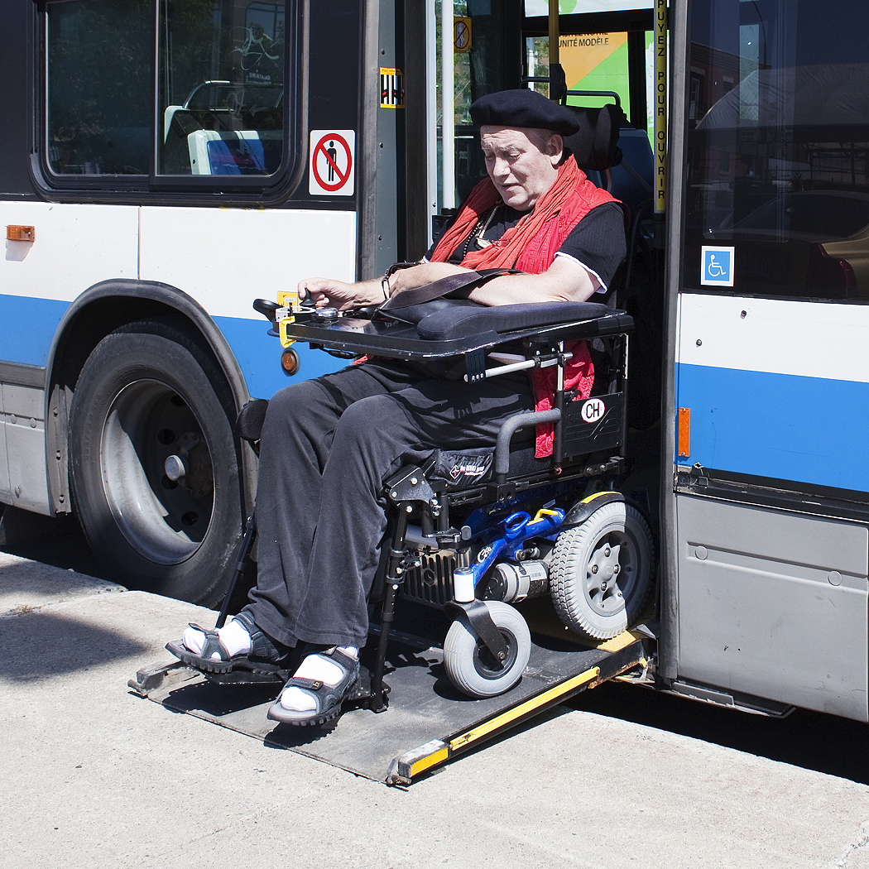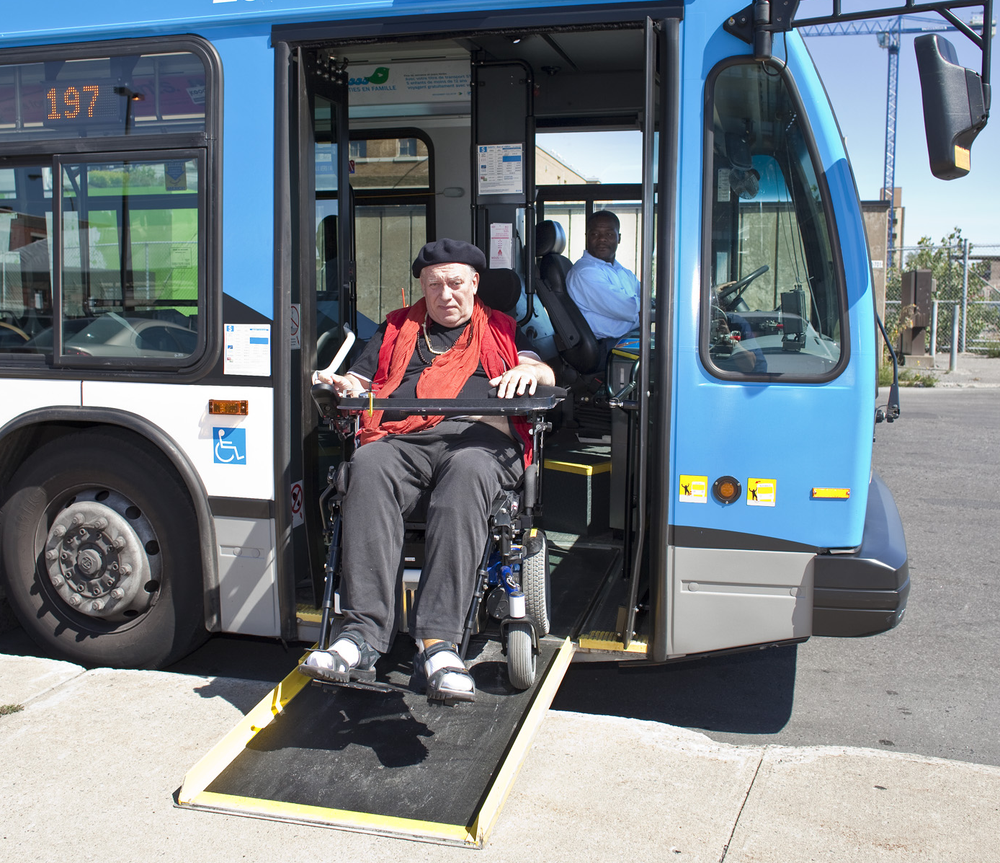
rear door ramp Front door ramp

There are currently two types of ramps on the low-floor buses. On the buses that went into service between 1996 and 2008, the ramp is located at the rear door of the bus. Since 2009, on the buses with the blue front, the ramp has been located at the front door of the bus.

Whether they’re at the front or at the rear, all low-floor buses ramps have a width of 30 inches (76 cm).
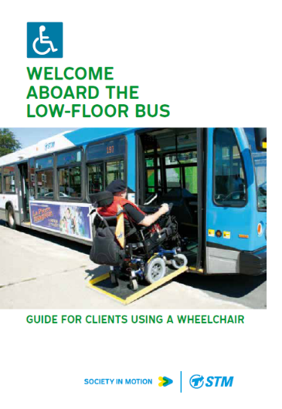
In comparison, the hydraulic platform on the Transport adapté minibuses is between 30 ¾ and 31 ¼ inches
(78 – 79 cm) wide, and the platform for the accessible taxis is 30 inches (76 cm) wide.

See? Our buses are well-equipped to accommodate you.
Feel like trying the accessible network? Order the guide, Welcome aboard the low-floor bus. Call the STM Comments line at 514 786-4636, option 4 and option 1. The guide is free!

The new vintage of minibuses
At the public meeting of the board of directors on October 13, the STM approved the purchase of 14 new minibuses for Transport adapté. Nothing new in that, you might say. It’s true that the STM regularly buys new minibuses to renew its fleet of vehicles. However, the 2011 vintage will include noticeable improvements both in the passenger area and under the hood.

First, for the mechanically inclined, it should be noted that the new minibuses will be built by Crestline on a GM chassis and will be equipped with a urea injection engine. Urea is a non-toxic product that transforms polluting gases into harmless
substances. This improvement in terms of sustainable development is already excellent news, but it doesn’t stop there!

The new minibuses will have a much smoother ride thanks to a pneumatic suspension system. With the addition of air-conditioning, they will also be more
comfortable on very hot days. There is no doubt that clients will enjoy a more pleasurable ride aboard these new vehicles.

In each edition, a half-page will now be reserved for organizations associated with Transport adapté. This section will enable you to learn more about the services they provide.

Transport Contact opens its pages to its partners
Le Regroupement des usagers du transport adapté et accessible de l’île de Montréal (RUTA de Montréal) represents paratransit users and people who have

functional limitations with regard to public transit.

Our work consists of becoming involved in files relating to transportation and assuring ourselves that the needs of the people we represent are being considered when decisions are made. Whether it’s the Ville de Montréal, the Agence métropolitaine de transport, the ministère des Transports du Québec, or even the STM, we encourage consultation and dialogue and promote the concept of universal accessibility. Everything that relates to the use of the public transit network attracts our attention, whether it’s the bus and métro network or paratransit.

Our role is to represent you. Call us!

Help us to help you

Reservations during the holiday period

From December 25 to January 2, all regular trips are cancelled, except those for hemodialysis appointments. If you wish to reserve trips during this period, you can do so up to 7 days in advance.

Are you returning earlier on December 24?

Often, activities end earlier on Christmas Eve. As of December 17, you’ll be able to change the return time for a trip scheduled for December 24.

These requests should be made by telephone at 514 280-8211, option 1.

This winter, think about clearing snow from entrances

Snow and ice often make boarding areas difficult to access.

Entranceways and stairs must be clear of snow and ice. Nor should there be snow banks blocking the Transport adapté driver’s access to your residence. You must also make sure that there is clear access at your destination.

If the entrance at your departure or destination point is snow-covered or icy, please cancel your trip. By doing this, you’ll prevent the driver from making an unnecessary trip to your home.

Snowstorms

Getting around is difficult for everyone during a snowstorm. On these days, it’s safer not to go out unless absolutely necessary.

If you decide to stay at home and you cancel a regular trip, don’t forget to cancel the return trip.

When weather conditions make it necessary for the STM to suspend its paratransit service, the decision is always made in the morning before the call centre opens and prior to the first trips.

The media are always advised of a suspension in paratransit service, so stay tuned…

To reach us

A single number to remember: Telephone: 514 280-8211

Requests for group transportation

Fax: 514 280-5317 E-mail: groupes.ta@stm.info

Teletype for hearing-impaired clients (TTY): 514 280-5308

Requests for regular transportation and
Advance requests for transportation

Fax: 514 280-6313

Website : www.stm.info

Customer Service: E-mail: transport.adapte@stm.info

Preferred addresses: E-mail: adresses.favorites@stm.info

STM Centre de transport adapté
3111 Jarry St. East
Montréal (Québec)
H1Z 2C2

Transport Contact is an information newsletter published by the STM’s Communications and Customer Service department.

Editorial: Denis Duquette

English Translation: Sally Davidson

Graphic design: Cécile Dion / Michel Gagnon

Photography: Guy Payment / Louis-Étienne Doré

May be reproduced if source is mentioned.

Pour obtenir la version française du Transport Contact, veuillez communiquer avec le Service à la clientèle au 514 280-8211 (option 4). Nous vous en posterons un exemplaire avec plaisir.


