Avoid waiting for the call centre while making it easier on yourself! With SIRTA, the online reservation website is always available. Please note, to reserve any transportation for the next day, the reservation must be completed by 9 pm the day before.

1) Registration 2
2) Forgotten password 3
3) Overview of your file 3
4) My profile 5
5) Request for occasional transportation 7
a) Request a Montreal trip 7
b) Request a Metropolitan trip 10
c) Add additional information for the address 11
6) Choose an address 12
7) Trips Overview: My schedule for the next 7 days 18
8) Request for regular transportation 20
9) My regular transportation schedule 23
10) Requests for trips in process 24

- Registration

Once you are on the SIRTA home page, you must enter your file number and password. It’s the same password you use for Transport adapté’s automated telephone services.

When you use the online reservation service for the first time, you will have to enter the month and date of your birth as your initial password (if you were born on September 14th, the password is 0914). Then, you will have to create your internet password before making that first reservation. Your new password must consist of 8 characters, including at least 1 number, ex: welcome9.

If you have forgotten your password, click on forgot my password, or for any other comment, please contact us by email or telephone at 514-280-8211 option 4.

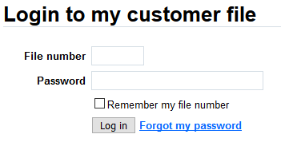

- Forgotten password

If you have forgotten your password and that you have your file number and the email registered to your file, you can reset your password online by clicking on forgot my password. Once you have sent your request, you will receive an email with the instructions to follow.

If you have forgotten your registered email, please contact us by email or telephone at 514-280-8211 option 4.

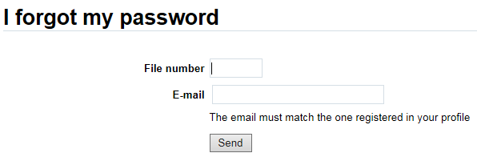

- Overview of your file

Once you are registered, you can view all relevant information in your reservation file.

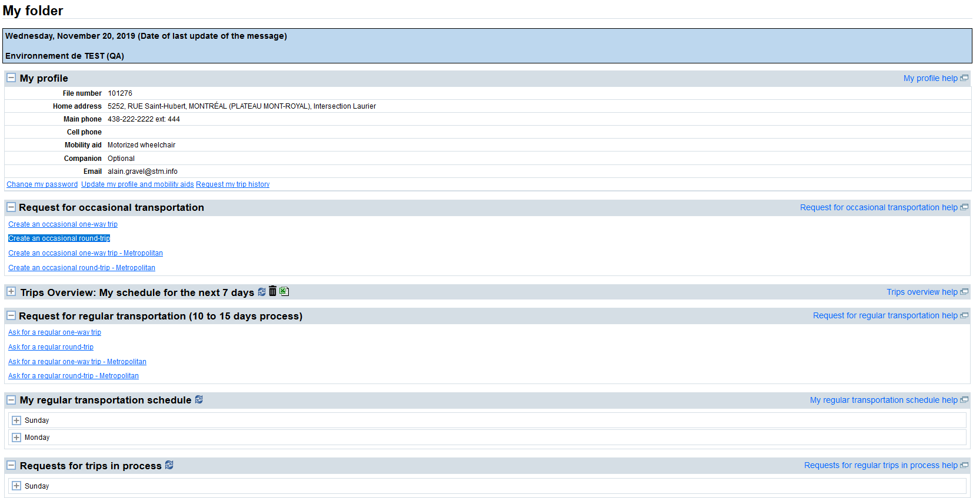

- My profile

You will find information regarding your Transport adapté’s file:

- File number
- Home address
- Main phone
- Cell phone
- Mobility aid
- Travel companion
- Email address

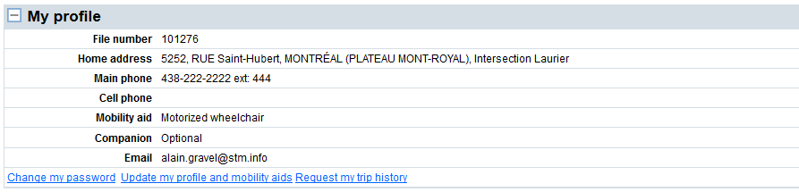

You can also access “Modify my password,” “Update my profile and mobility aids” and “Request my trip history.”

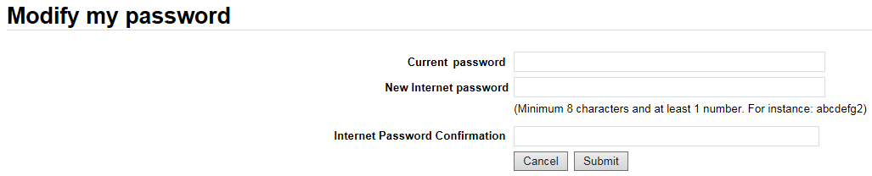

Your current password is your actual internet password that you wish to modify. Then, you will have to create a new internet password, it must consist of 8 characters, including at least 1 number, ex: welcome9.

- Request for occasional transportation

After deciding if you want a one-way trip or a round trip when travelling in Montréal or off the island of Montréal but within the service area covered by the ARTM (Autorité régionale de transport métropolitain), you must enter the required information:

  - Requested date
  - Requested time using 24-hour format [hh:mm]
  - Departure and destination addresses
  - Additional information for the address
  - Required mobility aid, if applicable
  - Number of travel companion(s), if applicable

Request a Montreal trip

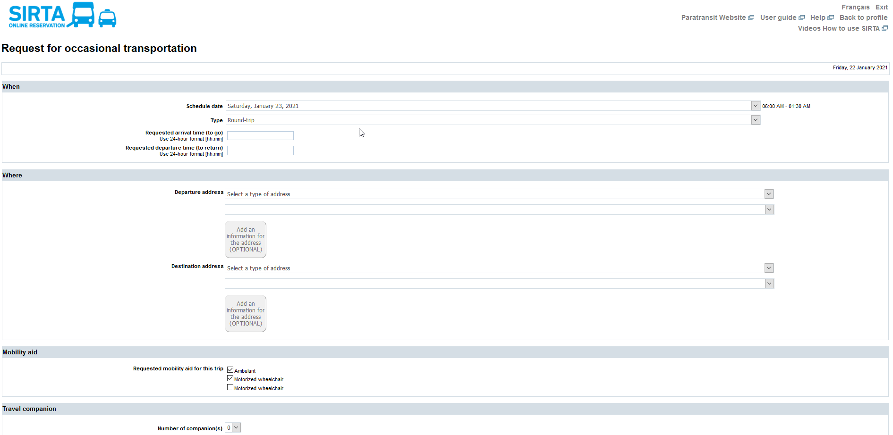

Once your reservation is confirmed, you can then modify or cancel if necessary. Be sure to verify the summary of the requested reservation. It is your responsibility to ensure that the addresses and booking information are accurate.
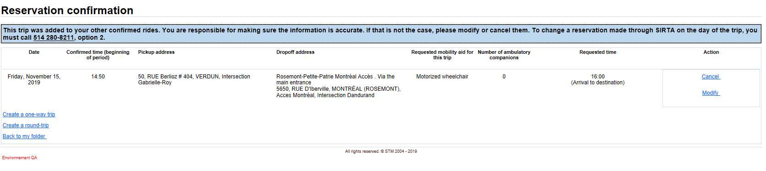

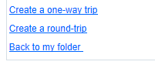

The above window makes it possible to create other trips by using one of the shortcuts.

Request a Metropolitan trip

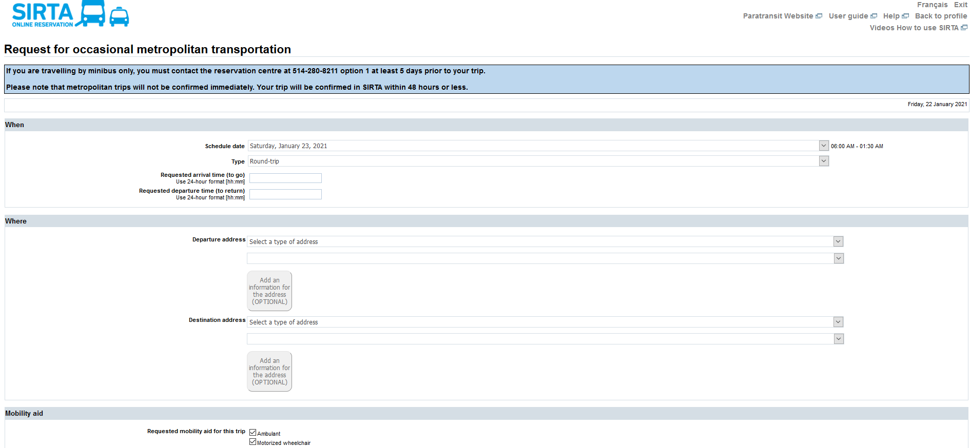

You will then receive a confirmation of receipt of the reservation request, which can be cancelled if needed. Make sure to properly verify the summary of the requested reservation. It is your responsibility to ensure the accuracy of reservation addresses and information. The request will be processed within 48 hours and by no later than 6 p.m. the day before your trip. Your request will not be immediately confirmed and can be found in the ‟Request for trips in process” section pending confirmation.

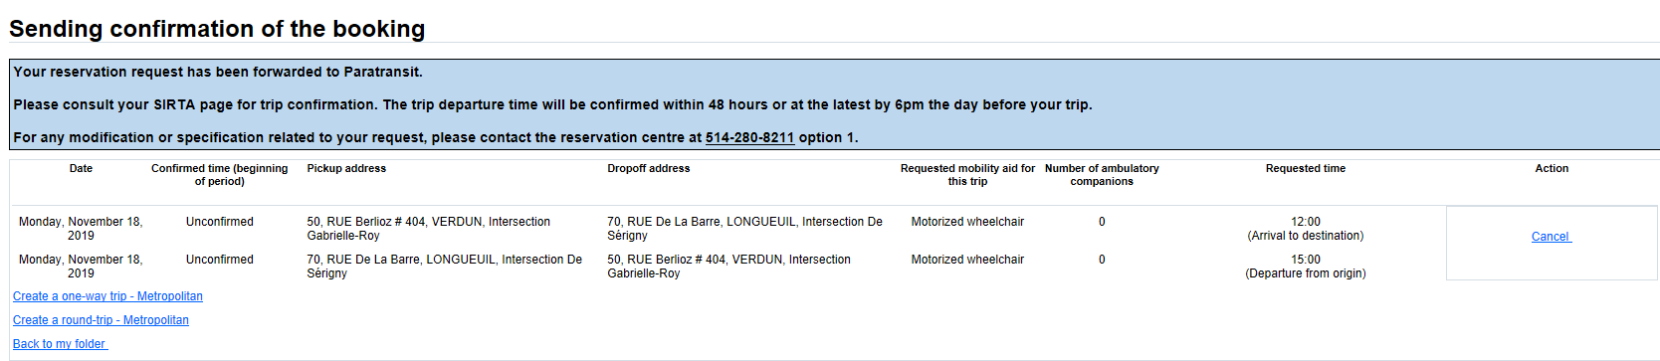

Add additional information for the address

You can add additional information to an address. This optional feature allows you to notify Transport adapté of any specifics related to your pick-up or drop-off at a specific address to help them find the location.
- Once you have chosen your address, a button will become available allowing you to add additional information to an address. The button will be unavailable (greyed out) for certain addresses for which the pick-up/drop-off location is pre-set for all customers.
- The information will automatically be saved to your file and applied to all future trips to that address unless you check the “Temporary” box, which will apply the information to only that trip.

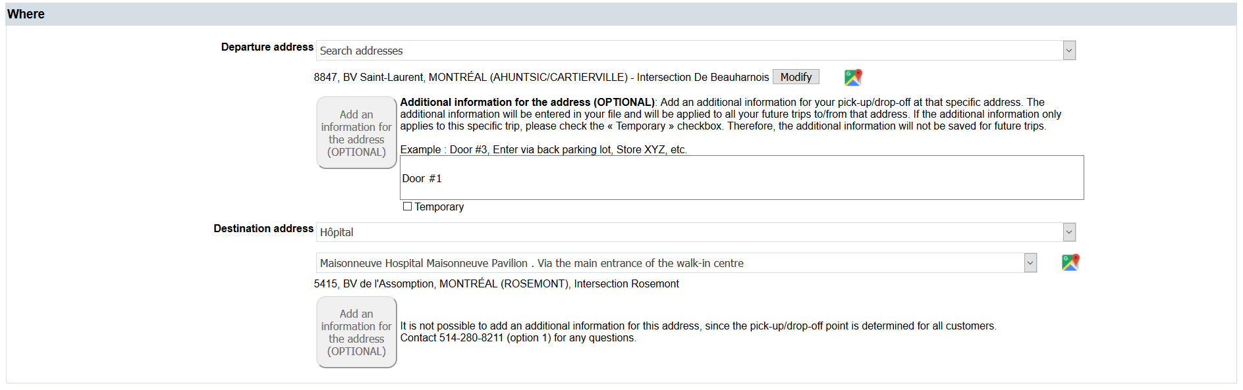

- Choose an address

When selecting your departure and arrival addresses for a request for occasional or regular trip, you can find your addresses from different lists offered.

- Search an address allows you to search for a new civic address where you want to travel for the very first time. After a first booking for this address, it will be added to your address history for a quick selection.

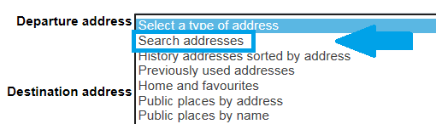

You must register a civic number and a street name to start the search. Direction and apartment number are optional fields. The street name must contain only the name of the street, do not enter the street type such as "street", "boulevard", "avenue", "road", etc.

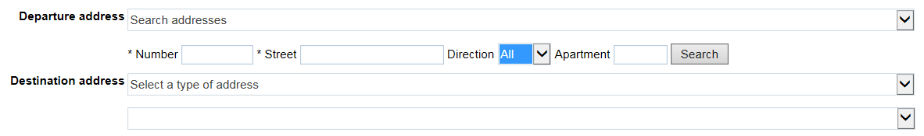

Then, select the desired address from the list of addresses found by clicking on the “Choose” button that is located right next to the desired address.

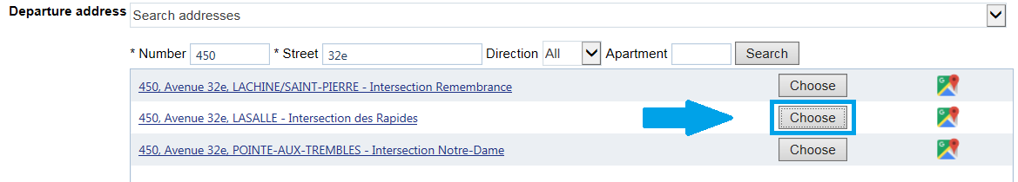

To make sure that the chosen address matches the desired address, you can click on the "Google Maps" icon which is located on the right end of each address to see the address on the map that will open in a new window.

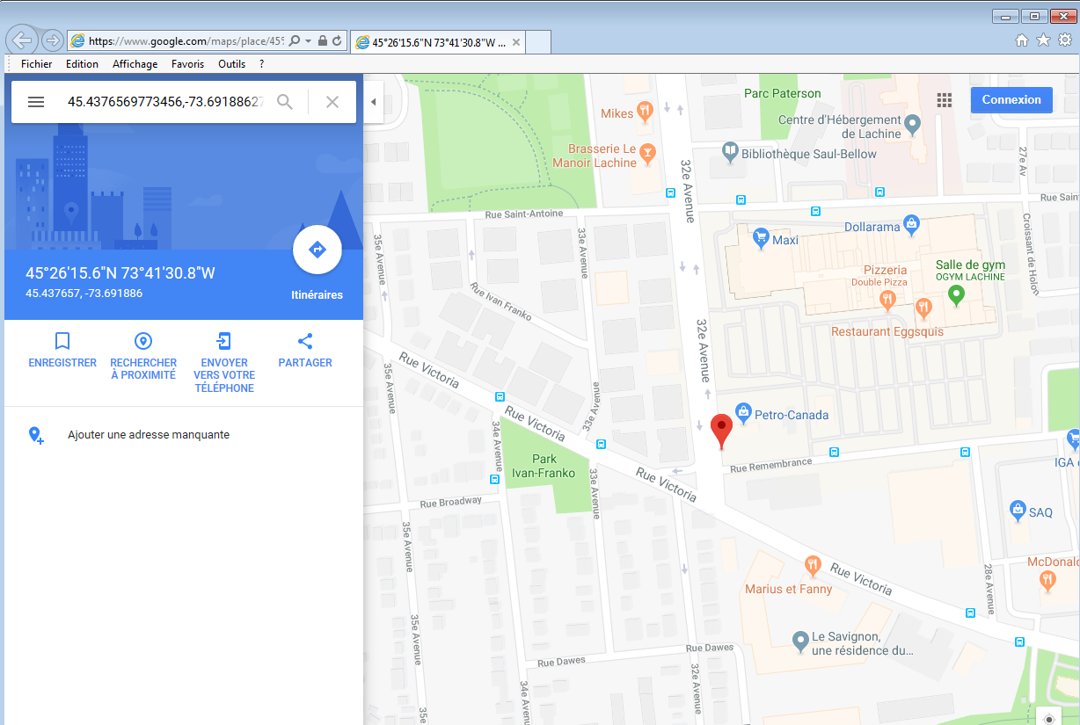

Once the desired address is selected, it is possible to click on the “Modify” button that sits on the right end of the address to change the chosen address.

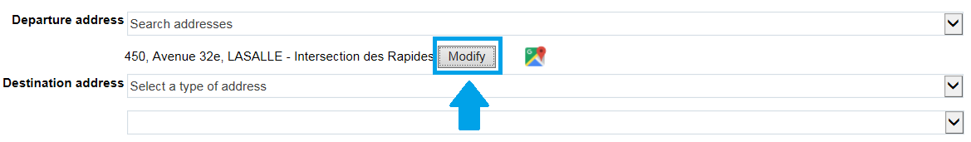

- Your history addresses and previously used addresses sorted by address or date of use represents all of your “from” and “to” addresses.

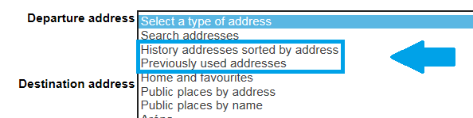

- Your Home and favorites includes your home address and favorite addresses.

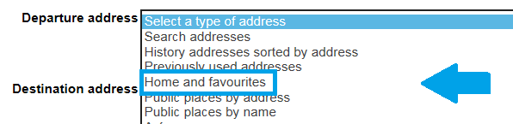

- Lists of several public places sorted by address, by name or by category, make it possible to look for a place commonly served by STM Paratransit such as hospitals, schools, shopping centers.

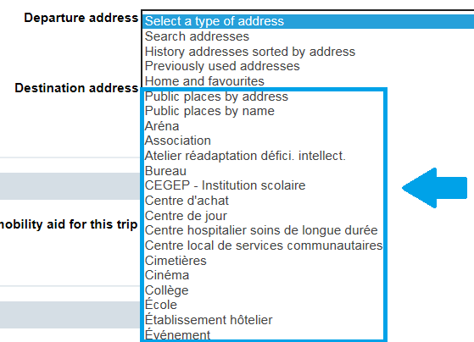

- Trips Overview: My schedule for the next 7 days

You can view your trip reservations for the next 7 days, regardless of whether they were made by phone or online.
You can view your trip reservations for the next 7 days, cancel them in batches or export them, regardless of whether they were made by phone or online.

A useful tool to:

- Have an overall view of your upcoming trips so you can enter them in your daily planner
- Make sure your reservation was correctly registered in the system
- Cancel a trip online
- Report a delay on the day of your trip online

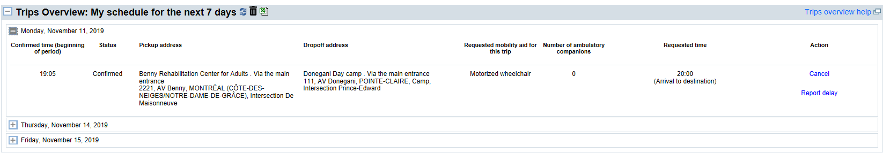

To cancel trips by batch, click on and select the dates and trips you wish to cancel, or check the box on the upper left side to cancel all of them. Then click Yes to confirm the cancellation of the selected trips.

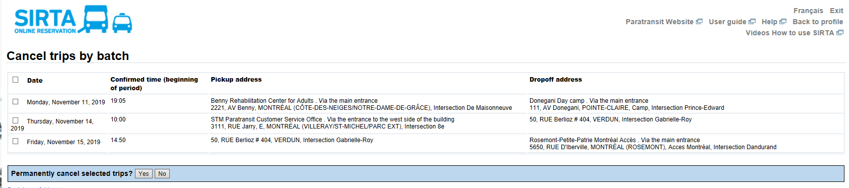

- Request for regular transportation

After deciding if you want a one-way trip or a round trip for Montreal or a Metropolitan trip, you must enter the required information :

  - Requested day(s)
  - Desired start date
  - End date (optional)
  - Period (every week or every 2 weeks)
  - Departure destination addresses
  - Additional information for the address
  - Required mobility aid, if applicable
  - Number of travel companion(s), if applicable
  - Optional comments (For instance, please specify if the trip is for hemodialysis)

Expect a 10 to 15 days waiting period before obtaining confirmation for your regular trips schedule, as this will require special programming in the system by a Transport adapté’s staff member. You must book occasional trips until the confirmation of your regular schedule.

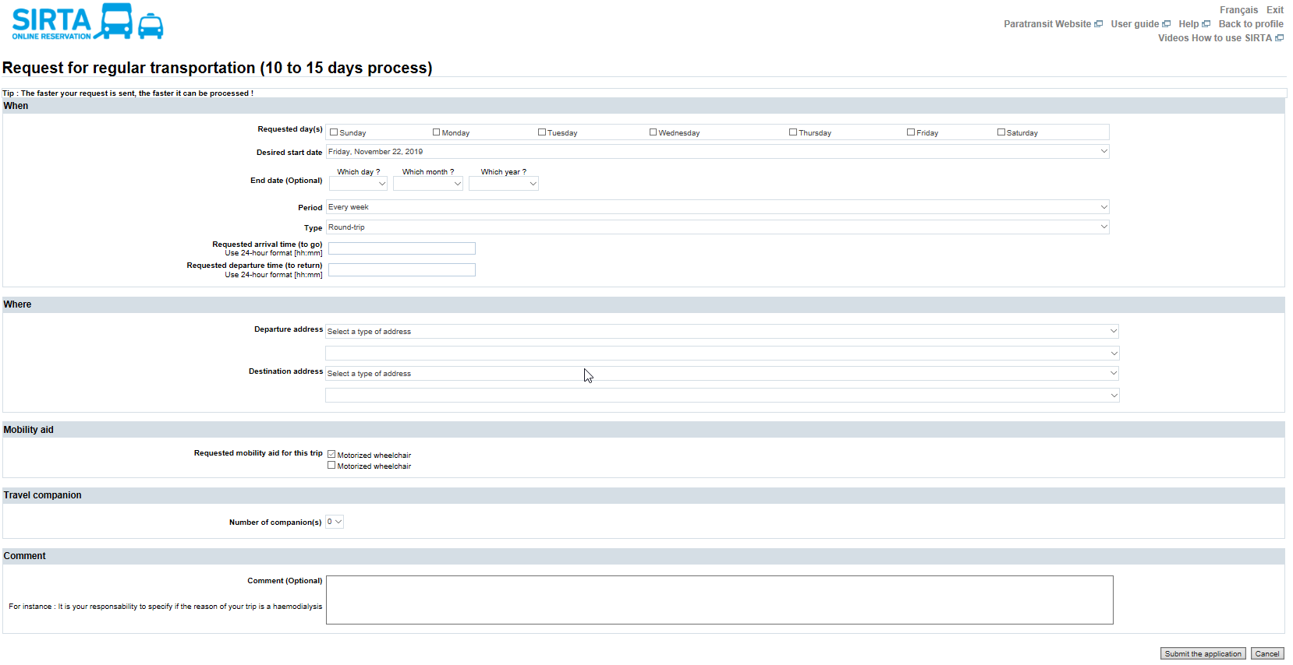

Once you have submit your request, a sending confirmation will appear, you can then cancel it if necessary.

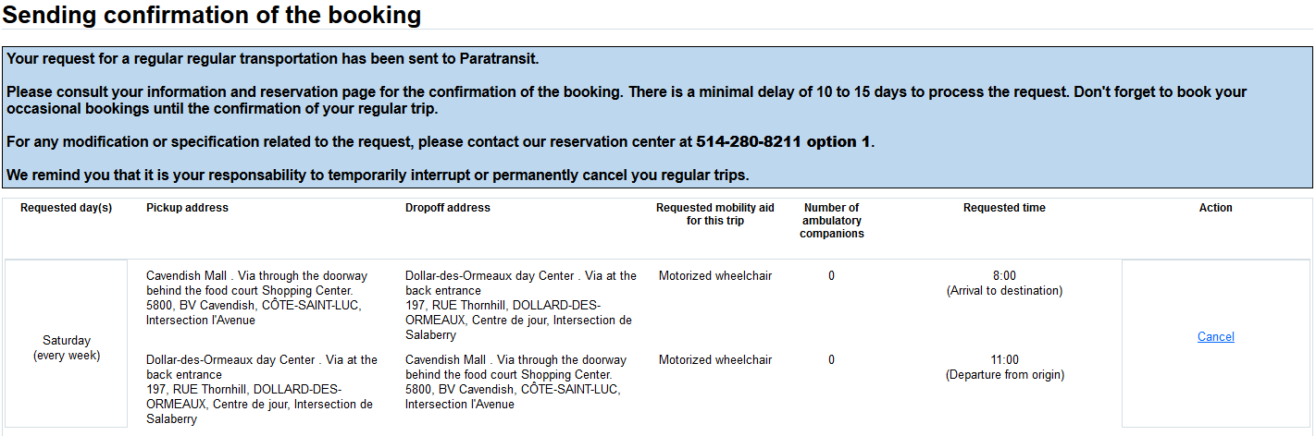

After submitting a request for regular transportation, you can access to your unconfirmed request in the section
Requests for trips in process. Once the transport adapté has process and confirm your trip, it will appear in SIRTA in the section My regular transportation schedule.

- My regular transportation schedule

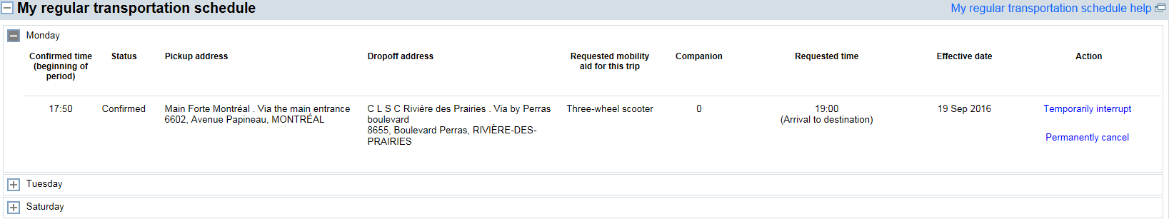
You can view your reservations for the regular trips registered in your file, regardless of whether they were made by phone or online. You can “temporarily interrupt” a regular transportation or “permanently cancel” it as needed.

- Requests for trips in process

You can have an overall view of your requests for regular trips that are still in process, regardless of whether they were made by phone or online. These trips are not yet confirmed by the Transport adapté. The status shows unconfirmed. Please note that you can cancel your request if needed. Once it has been processed and confirmed, it will appear in SIRTA in the section. My regular transportation schedule and in the section Trips Overview : My schedule for the next 7 days for Metropolitan occasional trip.

