Avoid waiting for the call centre while making it easier on yourself! With SIRTA, the online reservation website is always available. Please note, to reserve any transportation for the next day, the reservation must be completed by 9 pm the day before.

1. Registration 2
2. Forgotten password 3
3. Overview of your file 3
4. My profile 5
5. Request for occasional transportation 6
6. Trips Overview: My schedule for the next 7 days 9
7. Request for regular transportation 10
8. My regular transportation schedule 13
9. Requests for regular trips in process 14

Registration

Once you are on the SIRTA home page, you must enter your file number and password. It’s the same password you use for Transport adapté’s automated telephone services.

When you use the online reservation service for the first time, you will have to enter the month and date of your birth as your initial password (if you were born on September 14th, the password is 0914). Then, you will have to create your internet password before making that first reservation. Your new password must consist of 8 characters, including at least 1 number, ex: welcome9.

If you have forgotten your password, click on password forgotten, or for any other comment, please contact us by email or telephone at 514-280-8211 option 4 (8:30 a.m. to 4:30 p.m., Monday to Friday).

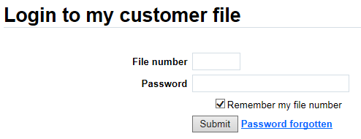

Forgotten password

If you have forgotten your password and that you have your file number and the email registered to your file, you can reset your password online by clicking on password forgotten. Once you have sent your request, you will receive an email with the instructions to follow.

If you have forgotten your registered email, please contact us by email or telephone at 514-280-8211 option 4 (8:30 a.m. to 4:30 p.m., Monday to Friday).

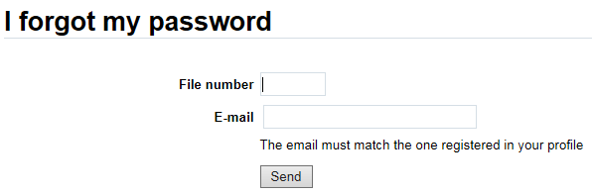

Overview of your file

Once you are registered, you can view all relevant information in your reservation file.

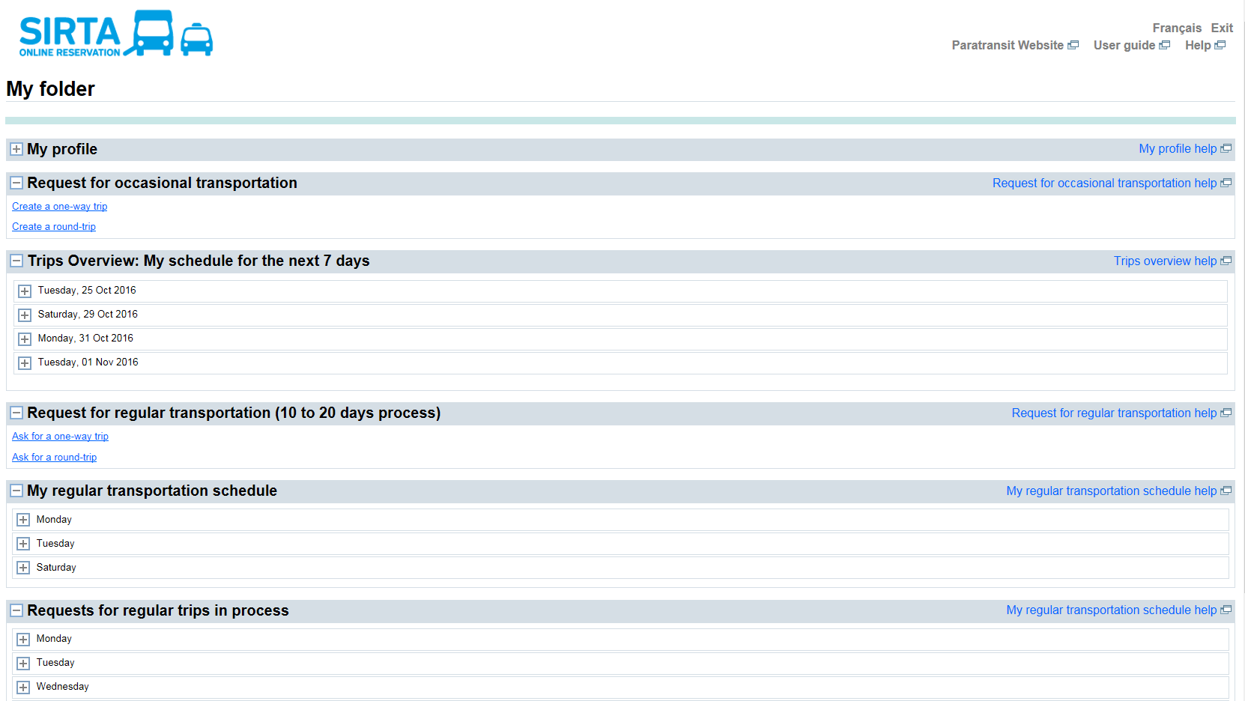

My profile

You will find information regarding your Transport adapté’s file:

- File number
- Home address
- Home phone
- Cell phone
- Mobility aid
- Travel companion
- Email address

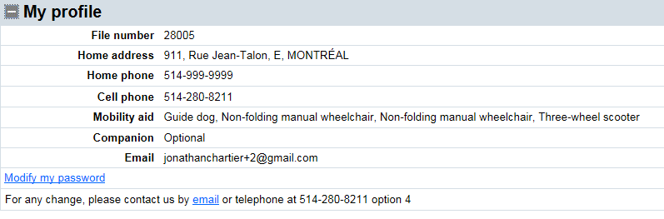

Also, you have access to modify your internet password.

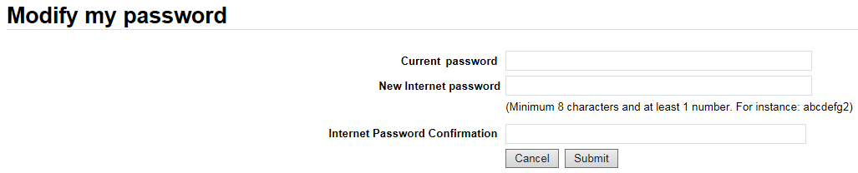

Your current password is your actual internet password that you wish to modify. Then, you will have to create a new internet password, it must consist of 8 characters, including at least 1 number, ex: welcome9.

Request for occasional transportation

After deciding if you want a one-way trip or a round trip, you must enter the required information:

  - Date and time
  - Departure and destination addresses
  - Mobility aid, if applicable
  - Travel companion, if applicable
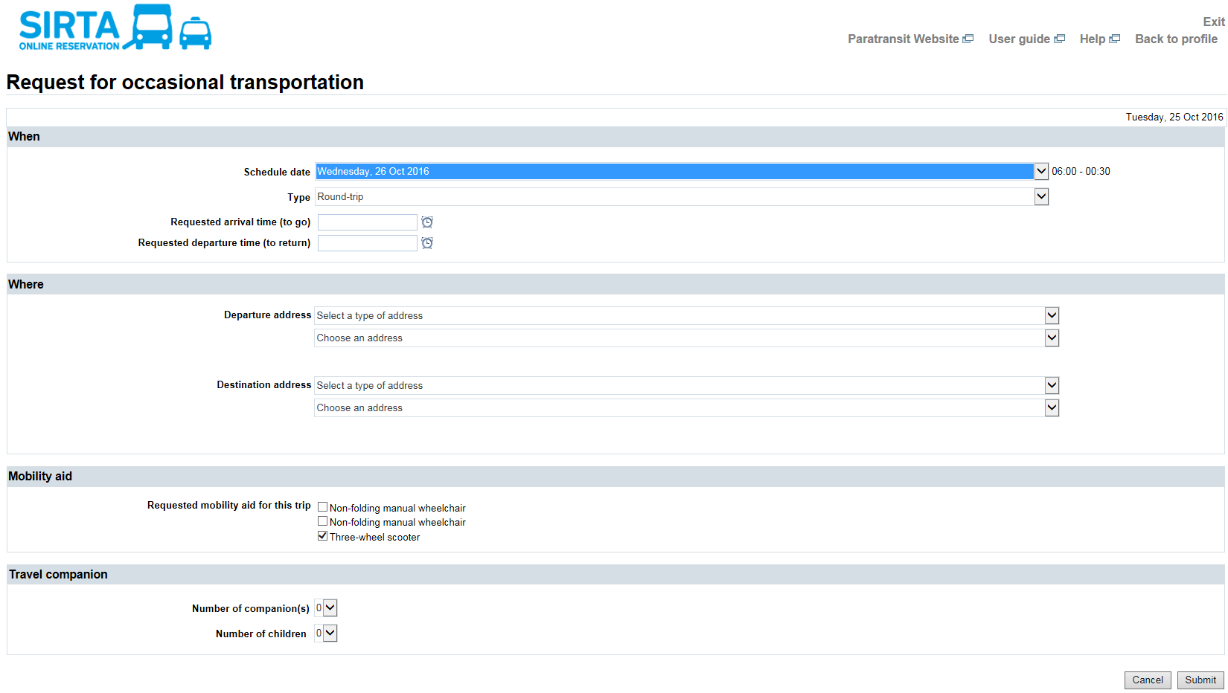

Once your reservation is confirmed, you can then modify or cancel it if necessary.

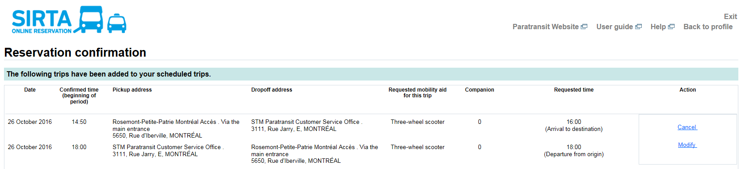

Trips Overview: My schedule for the next 7 days

You can view your trip reservations for the next 7 days, regardless of whether they were made by phone or online.

A useful tool to:

- Have an overall view of your upcoming trips so you can enter them in your daily planner
- Make sure your reservation was correctly registered in the system
- Cancel a trip online
- Report a delay on the day of your trip online

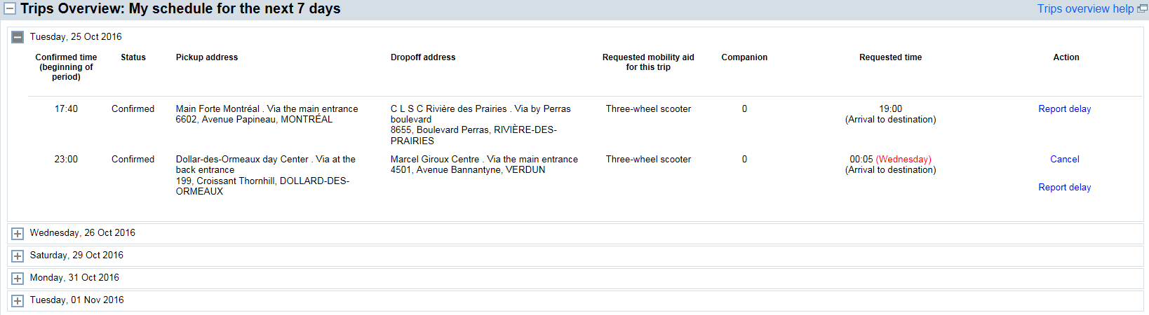

Request for regular transportation

After deciding if you want a one-way trip or a round trip, you must enter the required information:

  - Requested day(s) and date(s)
  - Period
  - Departure and destination addresses
  - Mobility aid, if applicable
  - Travel companion, if applicable
  - Comment (For instance, please specify if the trip is for hemodialysis)

Expect a 10 to 20 days waiting period before obtaining confirmation for your regular trips schedule, as this will require special programming in the system by a Transport adapté’s staff member.

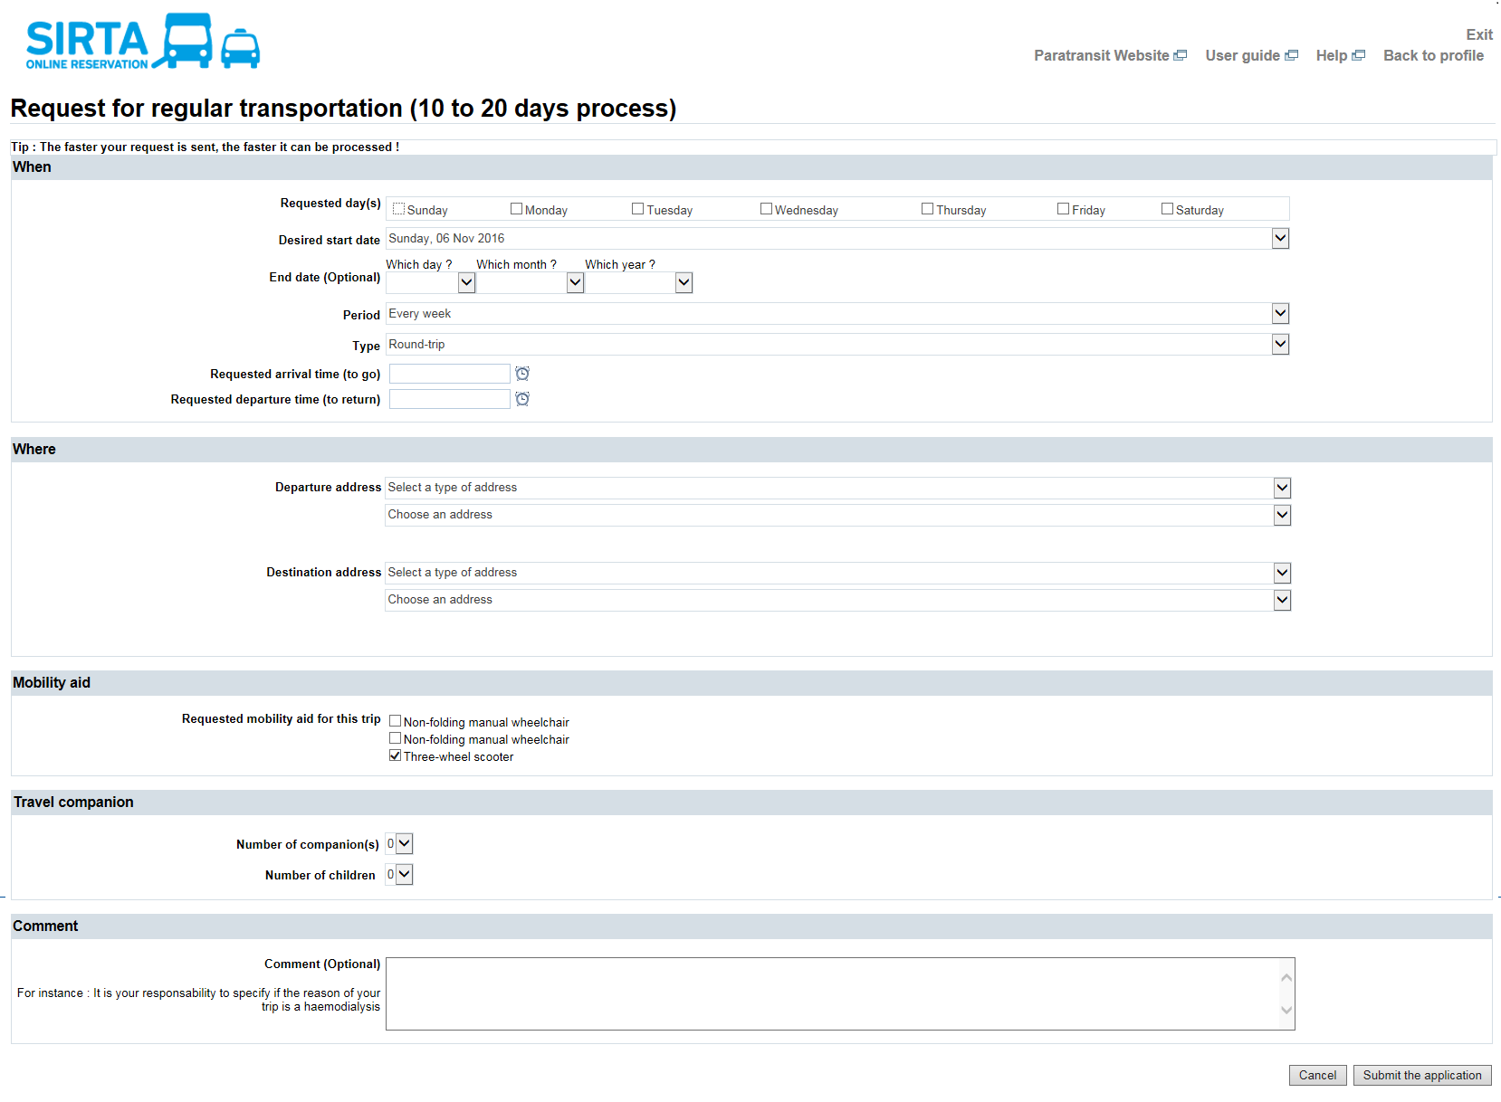
Once you have submit your request, a sending confirmation will appear, you can then cancel it if necessary.

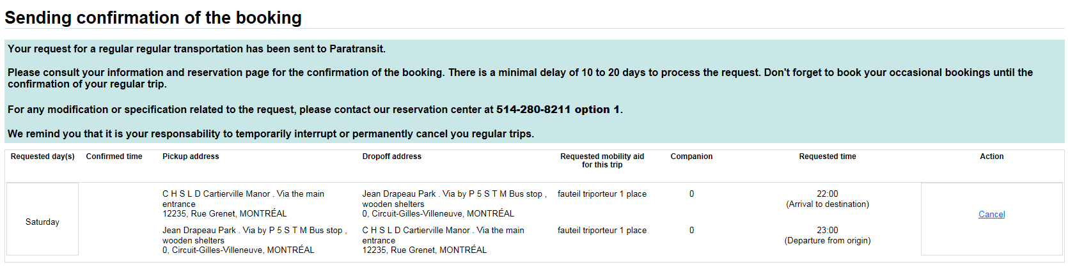
After submitting a request for regular transportation, you can access to your unconfirmed request in the section Requests for regular trips in process. Once the transport adapté has process and confirm your trip, it will appear in SIRTA in the section My regular transportation schedule.

My regular transportation schedule

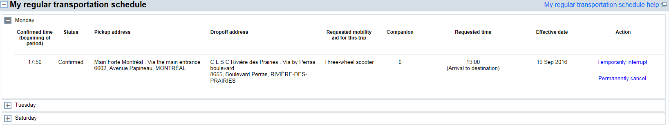
You can view your reservations for the regular trips registered in your file, regardless of whether they were made by phone or online. You can “temporarily interrupt” a regular transportation or “permanently cancel” it as needed.

Requests for regular trips in process

You can have an overall view of your requests for regular trips that are still in process, regardless of whether they were made by phone or online. These trips are not yet confirmed by the Transport adapté. The status shows unconfirmed. Please note that you can cancel your request if needed. Once it has been processed and confirmed, it will appear in SIRTA in the section. My regular transportation schedule.
